DEVELOPMENT OF A NETWORK INTRUSION DETECTION MODEL USING MACHINE LEARNING

TABLE OF CONTENTS
TITLE PAGE
DECLARATION. i
CERTIFICATION. ii
DEDICATION iii
ACKNOWLEDGEMENT iv
TABLE OF CONTENTS v
LIST OF TABLES....................................................................................................................... vii
LIST OF FIGURES viii
LIST OF EQUATIONS x
ABSTRACT xi
CHAPTER ONE 1
INTRODUCTION 1
1.1 Background of Study 1
1.2 Statement of Problem 3
1.3 Aim and Objectives 3
1.4 Significance of the Study 4
1.5 Scope of study 4
1.6 Definition of Terms 5
CHAPTER TWO 6
LITERATURE REVIEW 6
2.1 Overview of Network Intrusion Detection Model using Machine Learning 6
2.2 Review of Related Models and Literature 16
2.3 Related Works 12
CHAPTER THREE 18
PROJECT METHODOLOGIES 18
3.1 Proposed Methodology 18
3.2 Data Preprocessing 20
3.3 Machine Learning Algorithms 21
3.4 Evaluation metrics 24
3.5 Tools and Software 27
3.6 Modelling Stages 28
CHAPTER FOUR 29
RESULTS AND DISCUSSION 29
4.1 Modelling 29
4.1.1 Importing the Dataset 29
4.1.2 Data Cleaning and Manipulation 31
4.1.3 Relabeling Multiple Sub-labels to Binary Labels 32
4.1.4 Percentage distribution of the labels in both training and testing datasets 33
4.1.5 Label Encoding of the Training and Testing dataset 34
4.1.6 Separating Features (X) And Target Labels (Y) For Training and Testing 35
4.1.7 Feature Selection Using Recursive Feature Elimination 36
4.1.8 Feature Scaling Using Standard Scaler 37
4.1.9 Train Test Split 38
4.1.10 Handling Class Imbalance 39
4.1.11 Decision Tree Model 40
4.1.12 Support Vector Machine 41
4.1.13 K-Nearest Neighbors 41
4.2 Results of each of the model 44
4.3 Comparison with past works 54
CHAPTER FIVE 56
SUMMARY, CONCLUSION AND RECOMMENDATION 56
5.1 Summary 56
5.2 Conclusion 57
5.3 Recommendation 57
REFERENCES 59

LIST OF TABLES PAGE
Table 2.1: Summary of Related Work 12
Table 4.1: Comparison of training and testing time for each of the algorithm 44
Table 4.2: Comparison of the training and testing accuracy for the three algorithms 45
Table 4.3: Comparison of performance metrics on the normal label for the three models 46
Table 4.4: Comparison of performance metrics on the attack label for the three models 47
Table 4.5: Comparison of the AUC score of each model 48
Table 4.6: Comparison of results with previous studies 54

LIST OF FIGURES PAGE
Figure 3.1: Agile methodology for this project 19
Figure 3.2: Example of K-NN Algorithm 21
Figure 3.3: Example of the Decision Trees Algorithm 22
Figure 3.4: Example of Support Vector Machine Algorithm 23
Figure 3.5: Example of confusion matrix 25
Figure 3.6: Area Under the ROC curve 26
Figure 4.1: Loading the dataset 29
Figure 4.2: Preview of the NSL-KDD training dataset 30
Figure 4.3: Preview of the NSL-KDD testing dataset 30
Figure 4.4: Dropping Unnecessary columns 31
Figure 4.5: Check Null Values 31
Figure 4.6: Label column to Binary classification 32
Figure 4.7: Preview of the attack_category column for both the training and testing dataset 32
Figure 4.8: Percentage of Normal and Attack Labels in the NSL-KDD training dataset 33
Figure 4.9: Percentage of Normal and Attack Labels in the NSL-KDD testing dataset 34
Figure 4.10: Encoding training and testing dataset 34
Figure 4.11: Preview of the encoded data 35
Figure 4.12: Splitting the features and target labels in both the training and testing dataset 35
Figure 4.13: Python code for Feature selection using recursive feature selection on data 36
Figure 4.14: Python code to scale the dataset 37
Figure 4.15: Train Test Split the training dataset 38
Figure 4.16: Code to handle class imbalance 39
Figure 4.17: Training the Decision Tree model 40
Figure 4.18: Training the Support Vector Machine model 41
Figure 4.19: Optuna library 42
Figure 4.20: Training the KNN model 43
Figure 4.21: A comparison of the training and testing accuracy of each of the algorithms 45
Figure 4.22: A comparison of the metrics on the normal label for each of the models 46
Figure 4.23: A comparison of the metrics on the attack label for each of the models 47
Figure 4.24: A graphical representation of the AUC score for each of the models 48
Figure 4.25: AUC-ROC curve for Decision tree model 49
Figure 4.26: AUC-ROC curve for Support Vector Machine 50
Figure 4.27: AUC-ROC curve for K-nearest neighbors model 50
Figure 4.28: Confusion Matrix of the Decision Trees 51
Figure 4.29: Confusion Matrix of the Support Vector Machine model on Testing 52
Figure 4.30: Confusion Matrix of the K-nearest neighbors model on Testing 53
Figure 4.31: Comparison of results with previous Studies 55

LIST OF EQUATIONS PAGE
Equation 3.1: Euclidean Distance metric formula 22

ABSTRACT
This study focuses on the Development of a Network Intrusion Detection Model Using Machine Learning that addresses the issues of network security. The study addresses the challenge of increasing cyberattacks and vulnerabilities on networks due to the development of new techniques and tools used by hackers. The aim of this study is to develop a network intrusion detection model using machine learning that detects attacks on the network effectively and efficiently while minimizing false positive rates. The study adopted the Agile methodology for its adaptability to changes. The Decision tree, Support Vector Machine and K-nearest neighbors were the algorithms used. The study adopted the Recursive Feature Elimination feature selection technique and the Standard Scaler feature scaling technique while also carrying out evaluation of the model’s performance using multiple metrics. The proposed model has been built and compared with other existing models and it has proven that the proposed model outperformed existing models by getting an accuracy of 99.99%, precision of 100%, recall of 100% and an f1-score of 100%. Recommendations include the implementation of user interface program that sends email alert notification on any attack detection.

CHAPTER ONE
INTRODUCTION
  - Background of the Study
Cybersecurity, a critical aspect of information technology, focuses on safeguarding systems from unauthorized access, data breaches, and malicious activities (Kaur & Ramkumar, 2022). Network security safeguards the fundamental networking infrastructure from unauthorized access, misuse, or theft. It encompasses establishing a secure foundation for devices, applications, users, and applications to operate seamlessly without compromising security (Cisco, 2023). Network security issues can be classified into three interconnected areas such as Confidentiality, Integrity and Availability. Confidentiality safeguards the privacy of information by preventing unauthorized access, Integrity ensures that information remains consistent, accurate, and trustworthy throughout its entire lifespan and Availability guarantees that authorized users can access information consistently and promptly (Chai, 2023). An Intrusion Detection System (IDS) is a monitoring system that detects suspicious activities and generates alerts when they are detected (Chkadmin, 2023). A Network Intrusion Detection System (NIDS) is a technology solution that monitors inbound and outbound traffic in your network for suspicious activity and policy breaches (Abubakar et al., 2022). According to Coulibaly (2020), anti-threat applications such as antivirus software, firewalls, and spyware-detection programs have become poor in detecting the latest malicious activities resulting from advanced tools and techniques that are used by both attackers and intruders. Networks have also become easy targets for attackers because of the large volumes of traffic going in and out. Different detection techniques can be used in monitoring this traffic in order to search for the attack patterns. Signature-based detection systems attempt to find signatures of an attack in the resource being monitored, whereas, in the statistical anomaly-based systems which is called Anomaly- based IDS (Abubakar & Garko, 2022). Due to the advancement of malicious techniques these systems have become obsolete, therefore the need for a network intrusion detection system that uses machine learning algorithms to classify normal and attack traffic (Khraisat et al., 2019). Existing network intrusion detection system lack in terms of accuracy as well as other evaluation metrics and require large computing power which makes organizations run from it. Therefore, this project aims to build a machine learning model that uses the K-nearest neighbors, Support Vector Machine and Decision Trees algorithms as well as multiple preprocessing techniques such as Label encoding, feature selection and feature scaling to effectively classify normal and attack traffic with limited computing resources and achieving high accuracy, precision, recall, f1-score and false positive rates. The successful integration of machine learning into Network Intrusion Detection Systems (NIDS) is a big deal for cybersecurity. It means better and smarter ways to detect network intrusions, making our online systems safer from advanced cyber threats. This project’s findings will show that using machine learning as technique for detecting network intrusion will improve network security.

  - Statement of the Problem
The massive usage of networks has resulted in the increase of vulnerabilities and security threats (Ahmad et al., 2020). Network leaks can lead to unauthorized access, data breaches, and financial losses. The traditional Network Intrusion Detection System methods, such as signature-based detection, firewalls are becoming increasingly ineffective due to how hackers have found vulnerabilities within them therefore making networks easily accessible to hackers. The number of cyberattacks has increased dramatically in recent years. There are an estimated 2.8 billion malware infections globally in 2022 (Ken, 2022). A 200% increase in DDoS attacks in 2023, with industries such as education, cloud, SaaS, retail, telecommunications, and media being targeted (Jackson, 2023). Network intrusions can occur in various locations, affecting networks, computers, mobile devices, internet of things devices globally. The lack of an effective Network Intrusion Detection System will affect individuals, organizations, and society as a whole that rely on secure digital communication. Therefore, this emphasizes the need for an enhanced network intrusion detection model that classifies attack and normal traffic on the network effectively.
  - Aim and Objectives
The aim of this project is to Develop a Network Intrusion Detection Model Using Machine Learning.
The Objectives of this project are:
- To gather dataset that is relevant to the project.
- To conduct detailed review of existing literature in the area of study.
- To build a machine learning model that can efficiently detect attacks.
- To evaluate the performance of all the machine learning algorithms in terms of accuracy, precision, recall, f1-score, Confusion matrix and AUC-ROC curve.
  - Significance of the Study
This project is important due to the fact that it addresses the challenges of securing a network from malicious attacks. The rise in network attacks, which is justified by a 200% increase in DDoS attacks in 2023 (Jackson, 2023b), emphasizes the need for a more improved machine learning model that classifies normal and attack traffic effectively and efficiently. This project aims to improve the performance of machine learning models in detecting malicious activity. The impact of this project is the provision of an improved machine learning model that makes the network safer.
  - Scope of the study
The focus is to build a more improved machine learning model for network intrusion detection using three algorithms with multiple techniques such as Label Encoding, Standard Scaling and Recursive Feature Elimination for feature selection in order to assess the model’s ability to classify normal and attack traffic. The model will be evaluated based on the accuracy, precision, recall, f1-score, confusion matrix and AUC-ROC curve. There will not be any GUI for this project.

  - Definition of Operational Terms
- Networks: A network is a group of two or more computers or devices that are interconnected for the purpose of exchanging data and sharing resources
- Machine Learning: This is a field of artificial intelligence that allows systems to learn and improve from experience without being explicitly programmed.
- Network Intrusion Detection System (NIDS) is a technology created to monitor network traffic, identify patterns of malicious activities and generate alerts to notify administrators about security threats.
- Machine learning algorithms are computational models that allow computers to understand patterns and forecast or make judgments based on data without the need for explicit programming.
- Supervised learning is a type of machine learning algorithms where we used labeled dataset to train the model or algorithms.
- Cybersecurity refers to the practice of protecting computer systems, networks, and data from theft, damage, or unauthorized access. It involves implementing measures to ensure the confidentiality, integrity, and availability of information.

CHAPTER TWO
LITERATURE REVIEW
2.1 Overview of Network Intrusion Detection Model using Machine Learning
Research in network security is a domain of computer networking. One aspect of cybersecurity is the detection of unauthorized access and malicious activities within computer networks. Intrusion Detection Systems (IDS) play a vital role in monitoring network traffic and identifying malicious activities (Dini et al., 2023). The intrusion detection systems (IDSs) are designed to detect the intrusions within the network (N & Gupta, 2021). The importance of securing networks from unauthorized access, data breaches, and cyber threats is not mentioned enough, emphasizing the need for network security practices (Haripriya & Jabbar, 2018). By employing machine learning algorithms, this study seeks to develop a Network Intrusion Detection model capable of accurately and efficiently detecting attacks while minimizing false positives.
2.2 Review of Related Models and Literature
The detection of attacks on a network has been a crucial area of research in the field of network security. The development of an efficient network intrusion detection model is very useful in increasing the security of networks. Recent studies have shown the involvement of machine learning in the detection of attacks on a network to be very promising in terms of results. This literature review will therefore explore the various methods and techniques employed to develop a network intrusion detection system using machine learning algorithms. The review will also discuss the challenges faced in developing the model.
Instruction Detection System based on Support Vector Machine using BAT Algorithm by Ahmad and Senga (2017). This study makes use of the Support Vector Machine algorithm along with the BAT algorithm. The authors explained that evolutionary algorithms is a new technique used to solve various problems in the field of network security. Therefore, to overcome these deficiencies of the Intrusion detection system, a new double detection Intrusion detection System based on the integration of evolutionary algorithm BAT and Support Vector Machine is employed. The proposed intrusion detection system using machine learning had an accuracy of 94.3%. The system could only detect known attacks but couldn’t detect unknown attacks efficiently and requires a good preprocessed dataset to work well.
An Intrusion Detection Framework Based on Hybrid Multi-Level Data Mining by Hu et al. (2017). The authors specified four main characteristics of intrusion data that affect the performance of IDS including multi-component, data imbalance, time-varying and unknown attacks. Therefore, they introduced a novel IDS framework called HMLD to address these issues, which is an exquisite designed framework based on Hybrid Multi-Level Data Mining. In this paper, In the classification phase, many machine learning algorithms (SVM, ANN, DT, and RF) which are all supervised learning algorithms are compared on different parameters. FIMS is applied as a feature selection technique. They used the KDDCUP99 dataset to evaluate the performance of the HMLD. The experimental results show that HMLD can reach 96.70% accuracy which is nearly 1% higher than the recent proposed optimal algorithm SVM+ELM+Modified K-Means. In details, HMLD greatly increased the detection accuracy of DoS, U2R, Probe and R2L attacks. The drawback with the FIMS approach is that the correlation between the candidate features and their class is not considered.
An Ensemble Approach for Intrusion Detection System Using Machine Learning Algorithms by Rohit et al. (2018) proposed an ensemble approach to detect intrusion. They perform three tests to show how their approach proposed better results. They first performed normalization on the KDD Cup99 dataset, then, they use a correlation method to perform feature selection. The feature selection used information gain as a decision factor, and finally, they use an ensemble approach combining three algorithms: Naïve Bayes, PART, and Adaptive Boost. The result of each algorithm is then compared, and the average of the results or most voting results is used to decide the outcome. In addition, they use the bagging method to reduce the variance error. They obtained an accuracy of 92.9732% on the KDD Cup99 dataset using their solution.
A Clustering-SVM Ensemble Method for Intrusion Detection System by Dong et al. (2019), proposed a hybrid solution combining clustering with SVM. In their solution, they first used K-means clustering to process the data and divided it into different subsets. Then, they used SVM on each of those subsets. They tested their solution on the NSL-KDD datasets and they obtained an overall accuracy of 94.45%. In addition, compared to other methods their solution improved the detection rate. Their solution also requires less time processing compared to SVM algorithms using different parameters. However, the authors provided no information concerning the accuracy of each attack classification.
A Predictive Model for Network Intrusion Detection System Using Deep Neural Network by Abubakar and Garko (2021). The study adopted Cross Industry Standard Process for Data Mining (CRISP-DM) as one of the formal methodologies and python was used for both testing and training, using crucial parameters such as the learning rate, number of epochs, neurons and hidden layers which greatly determined the accuracy level of the DNN algorithm. These parameters were experimented with values that are lesser compared to previous studies, training and evaluation that were also done on the KDD99 data-set. Therefore, the model with two layers attained same accuracy of 95.5% as the model with three layers from the previous study out of the four models tested in this study. Also, the models with three and four layers in this study attained an accuracy of 95.6%.
An effective intrusion detection approach using SVM with naïve Bayes feature embedding by Gu and Lu (2021) proposed a new solution to improve IDS using SVM. Their solution used Naïve Bayes algorithm to perform feature selection. Then, they trained the model with the transformed data from the feature selection. They tested their solution on the UNSW-NB15 and the CICIDS2017 datasets. Compared to using only the SVM classifier, the use of Naïve Bayes for feature extraction before using the SVM classifier shows better results. Indeed, they obtained an accuracy of 93.75% on the UNSW-NB15 dataset and an accuracy of 95.2% on the CICIDS2017 dataset. However, their solution only shows if there is an intrusion, it cannot be used to detect what kind of attack is in operation.
Network intrusion detection system using deep neural networks by Mohammed et al. (2021). The main idea of this paper is to use an advanced intrusion detection system with high network performance to detect the unknown attack package, by using a deep neural network algorithm, also in this model, the attack detection is done by two ways (binary classification and multiclass classification). Through this experimental research of multi-class classification, which had been found in the KDD cup 99 datasets, the authors have shown that supervised learning models, which are DNN, are capable of detecting and classifying with high accuracy, and this detection was executed on network packet analysis and connection parameters without packet payload information. The proposed system has shown encouraging results in terms of the high accuracy (92.18% with multiclass classification and with binary classification).
Network intrusion detection using oversampling technique and machine learning algorithms by Hafiza et al. (2022) presents a framework in which different machine learning classification schemes are employed to detect various types of network attack categories. Five machine learning algorithms: Random Forest, Decision Tree, Logistic Regression, K-Nearest Neighbors and Artificial Neural Networks, are used for detection. This study uses a dataset published by the University of New South Wales (UNSW-NB15), a relatively new dataset that contains a large amount of network traffic data with nine categories of network attacks. The results show that the classification models achieved the highest accuracy of 89.29% by applying the Random Forest algorithm.
Intrusion Detection Systems using Supervised Machine Learning Techniques: A survey by Abdallah et al. (2022). The main goal of this study is to provide a taxonomy for linked intrusion detection systems and supervised machine learning algorithms. The classification performance of supervised learning algorithms is high and promising based on the study of four popular data sets in this domain: KDD’99, NSL-KDD, CICIDS2017, and UNSW-NB15. The emphasis on feature selection is important for the enhancement of the model’s performance. The proposed model had an accuracy of 91%, 94%, 90% and 93% for each of the datasets respectively.
Intrusion Detection System Using machine learning Algorithms by Tahri et al. (2022). In this paper, the focus was on the use of three different classifications algorithms; starting by machine learning, algorithms NB, SVM and KNN. These algorithms were used to define the best accuracy by means of the USNW NB 15 and NSL-KDD DATASETS. Based on the result of the modelling, the NB, SVM and KNN got 93%, 95% and 91% respectively for the USNW NB 15 dataset, while SVM and NB got 94.29% and 67% respectively for the NSL-KDD dataset. The model has performed excellently and has a conclusion that the SVM algorithm has a better accuracy in both datasets.
2.4 Related Works
Table 2.1: Summary of Related Work
The table contains an executive summary of works that are related to the project, include the name of the authors, Title of the work, Method, Findings and Limitations.
S/N | Name | Title | Method | Findings | Limitation
1 | Ahmad and Senga (2017) | Instruction Detection System based on Support Vector Machine using BAT Algorithm. | Support Vector  Machine using  BAT Algorithm  using decent  computing  resources. | Proposed intrusion  detection system that improves the detection accuracy and reduces false  alarm rate with accuracy reaches up to 94.3% | It doesn’t detect unknown attacks,  It also requires good preprocessed data.
2 | Hu et al. (2017) | An Intrusion Detection Framework Based on Hybrid Multi-Level Data Mining | The use of SVM, ANN, DT, and RF algorithms and HMLD framework. FIMS for feature selection. | The proposed approach has obtained an accuracy rate reaching 96.70% with the KDD-Cup ‘99 dataset. | The drawback with the FIMS approach is that the correlation between the candidate features and their class is not considered.
3 | Rohit et al. (2018) | An Ensemble Approach for Intrusion Detection System Using Machine Learning Algorithms | Correlation method to perform feature selection and use of an ensemble approach combining three algorithms: Naïve Bayes, PART, and Adaptive Boost. | They obtained an accuracy of 92.9732% | The proposed  system require more  training time but it  has self-adaptive  learning.
4 | Dong et al. (2019) | A Clustering-SVM Ensemble Method for Intrusion Detection System | They first used K-means clustering to process the data and divided it into different subsets. Then, they used SVM on each of those subsets. | They tested their solution on the NSL-KDD datasets and they obtained an overall accuracy of 94.45%. | The system takes time and requires a lot of computing power.
5 | Abubakar and Garko. (2021) | A Predictive Model for Network Intrusion Detection System Using Deep Neural Network | The study adopted Cross Industry Standard Process for Data Mining (CRISP-DM) as one of the formal methodologies and the DNN algorithm. | The system got an accuracy of 95.5% and 95.6% for each double layer. | Limited computing resources.
6 | Gu and Lu (2021) | An effective intrusion detection approach using SVM with naïve Bayes feature embedding | Proposed a solution to improve IDS using SVM algorithm. Their solution used Naïve Bayes algorithm to perform feature selection. | They obtained an accuracy of 93.75% on the UNSW-NB15 dataset and an accuracy of 95.2% on the CICIDS2017 dataset. | Their solution only shows if there is an intrusion, it cannot be used to detect what kind of attack is in operation.
7 | Maithem and Al-Sultany (2021) | Network intrusion detection system using deep neural networks | Using a deep neural network algorithm. | The proposed system has shown encouraging results in terms of the high accuracy (92.18% with multiclass classification and with binary classification) | dealing with unbalanced datasets.
8 | Ahmed et al. (2022) | Network intrusion detection using oversampling technique and machine learning algorithms | Five machine learning algorithms: Random Forest, Decision Tree, Logistic Regression, K-Nearest Neighbors and Artificial Neural Networks, are used for detection. | The results show that the classification models achieved the highest accuracy of 89.29% by applying the Random Forest algorithm. | Limited computing power and class imbalance problem.
9 | Abdallah et al. (2022) | Intrusion Detection Systems using Supervised Machine Learning Techniques: A survey | Using supervised learning techniques. | The proposed model had an accuracy of 91%, 94%, 90% and 93% for each of the datasets respectively. | Data imbalance can be a concern.
10 | Tahri et al. (2022)) | Intrusion Detection System Using machine learning Algorithms | Machine learning, algorithms NB, SVM and KNN are used for detection. | The SVM algorithm outperformed other algorithms with an accuracy of 95% and 94.29% in both datasets. | Lack of real time testing.

CHAPTER 3
PROJECT METHODOLOGY
3.1 Proposed Methodology
The Agile methodology is an iterative and incremental approach to development that prioritizes flexibility to change (Gaborov et al., 2021). It emphasizes collaboration, feedback, and the delivery of small, functional increments in short time frames, known as iterations (Ahmed, 2022).
According to Thesing et al., (2021), these are the reasons why Agile methodology is suitable for a project.
- Flexibility: Due to the increasing sophistication of cyberattacks, Agile’s flexibility allows to adjust quickly to emerging threats, changing requirements, and advancements in machine learning techniques.
- Agile methodology promotes iterative development, allowing for continuous improvement and adjustments.
- Agile methodology emphasizes the collaboration and communication between team members, even if you are working alone, you can seek feedback and advice from other experts in the field.
In Agile development methodology, the aim is to create small parts of software but in this case small parts of the model and improve them along the way. It’s crucial to get feedback from experts to make sure the model does what it’s supposed to do.
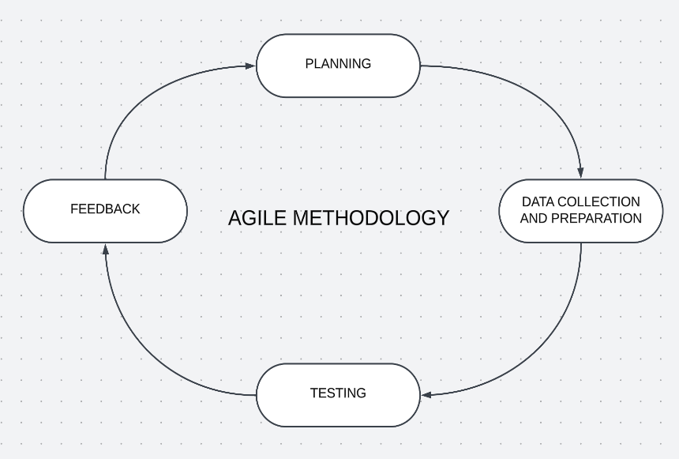
Figure 3.1: Agile methodology for this project
The following phases above in figure 4 are involved in the adopting of the Agile methodology into this project.
- Project Planning: Defining the project goals and objectives. Identify the key performance evaluation metrics that will be used to measure the success of the intrusion detection system.
- Data Collection and Preparation: Acquiring the dataset from Kaggle open source and preprocessing the network traffic dataset that will be used to train the machine learning model. This stage involves cleaning, transforming, standardization and label encoding of the datasets.
- Model Selection and Training: Selecting a machine learning algorithm such as a decision tree, random forest, Support Vector Machine. After building the algorithm, train the model on the training data.
- Testing: Carry out testing on the model to determine its performance. This involves the use of Sci-Kit Learn library in order to access the evaluation metrics like accuracy, recall, precision and confusion matrix.
- Feedback: Gathering feedback from my supervisors in order to improve the model.
  - Data Preprocessing
Data preprocessing of the dataset is carried out using different techniques in order to prepare the dataset for training. These techniques include:
- Recursive feature Elimination feature selection technique: this is a technique used to select the best features in the dataset. This technique orders the features from most important to the least, then removes the least important features from the dataset and then repeats the process 2-4 times (Jeon & Oh, 2020).
- Standard Scaler: This is the scaling technique used for this project. Feature scaling helps to transform values of features in the datasets to a specific range (Shafique et al., 2022).
- Label Encoding: This is the process of assigning a unique value to the values in the categorical features (Shafique et al., 2022).
  - Machine Learning Algorithms ‌
The machine learning algorithms used in this project include the K-nearest neighbor, Decision Trees and Support Vector Machine.
- K-nearest neighbor algorithm is a simple machine learning algorithm used for classification tasks where the model makes predictions for a new data point by calculating the distance between that point and every point in the training dataset (Hu et al., 2019). Optuna is a next generation hyper parameter optimization technique and it features an imperative and define-by-run style user API (Akiba et al., 2019).
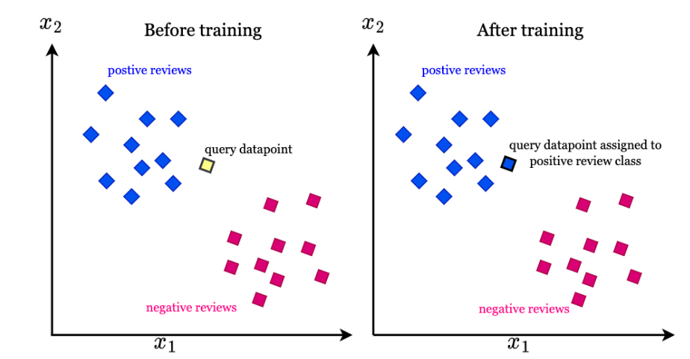
Figure 3.2: Example of K-NN Algorithm (Hu et al., 2019).
Figure 3.2 is a graphical representation of how the K-NN algorithm works.
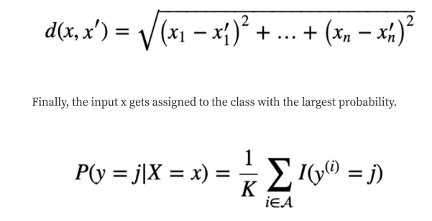
Equation 3.1: Euclidean Distance metric formula
Equation 3.1 shows the formula for calculating distance between points data points in the feature space.
- Decision trees are a type of supervised machine learning algorithm commonly used in classification problems (IBM, 2021). The goal of a decision tree is to create a model that predicts the value of a target variable by learning simple decision rules gotten from the features (Ahmed, 2021).
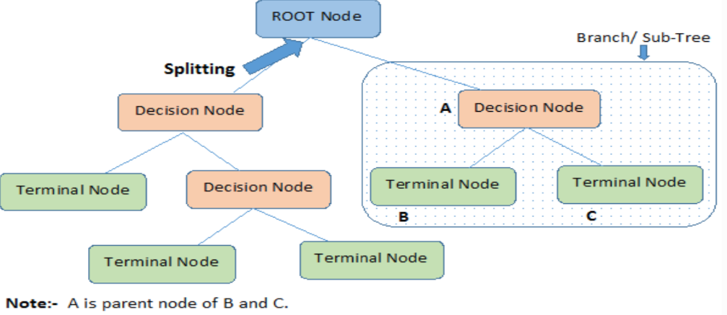
Figure 3.3: Example of the Decision Trees Algorithm
Figure 3.3 is a pictorial representation of the decision trees algorithm. Decision trees doesn’t have a single mathematical formula like other algorithms. Instead, its represented by a tree structure composed of decision nodes, branches, and leaf nodes (Chauhan, 2021).
- According to Ambika (2023), Support Vector Machine is a supervised machine learning algorithm that tries to find a hyperplane that best separates the two classes. Support vector machine is based on statistical approaches. SVMs are effective at handling high-dimensional data, which is often the case with network traffic datasets that contain many features.
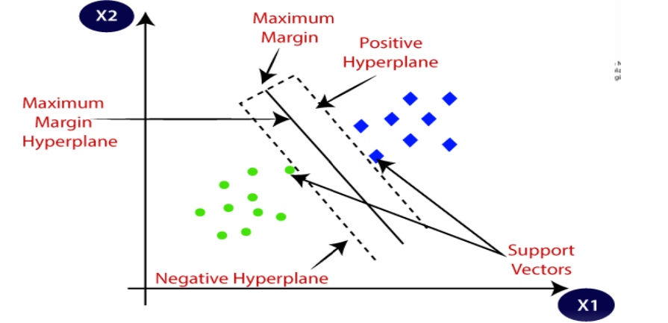
Figure 3.4: Example of Support Vector Machine Algorithm (Saini, 2024).
Figure 3.4 is a graphical representation of how the support vector algorithm works, Support Vectors are the points that are closest to the hyperplane. A separating line will be defined with the help of these data points. Margin is the distance between the hyperplane and the observations closest to the hyperplane (support vectors). In SVM large margin is considered a good margin (Saini, 2024).
  - Evaluation metrics
After the model is built, there needs to be an evaluation of the model’s performance. The following metrics will be used to assess the performance of this model.
- Precision: It is calculated as the ratio of true positives to the sum of true positives and false positives. It is a useful metric when false positives are costly. For example, in intrusion detection, a false positive would be marking a legitimate network traffic as an intrusion. Formula: Precision = True Positives / (True Positives + False Positives)
- Recall: Recall is the ratio of true positive predictions to the total actual positives.
Formula: Recall = True Positives / (True Positives + False Negatives)
- F1 Score: F1 Score is the mean of precision and recall, which gives equal weight to both measures. It is a metric used when there is a class imbalance in the data. Formula: F1-Score = 2 * (Precision * Recall) / (Precision + Recall)
- Accuracy: Accuracy is the ratio of the number of correct predictions to the total number of input samples. It can be misleading if there is a class imbalance in the data. Formula: Accuracy = (True Positives + True Negatives) / Total Instances
- Confusion matrix: A confusion matrix is a tabular representation used in machine learning to evaluate the performance of a classification model.

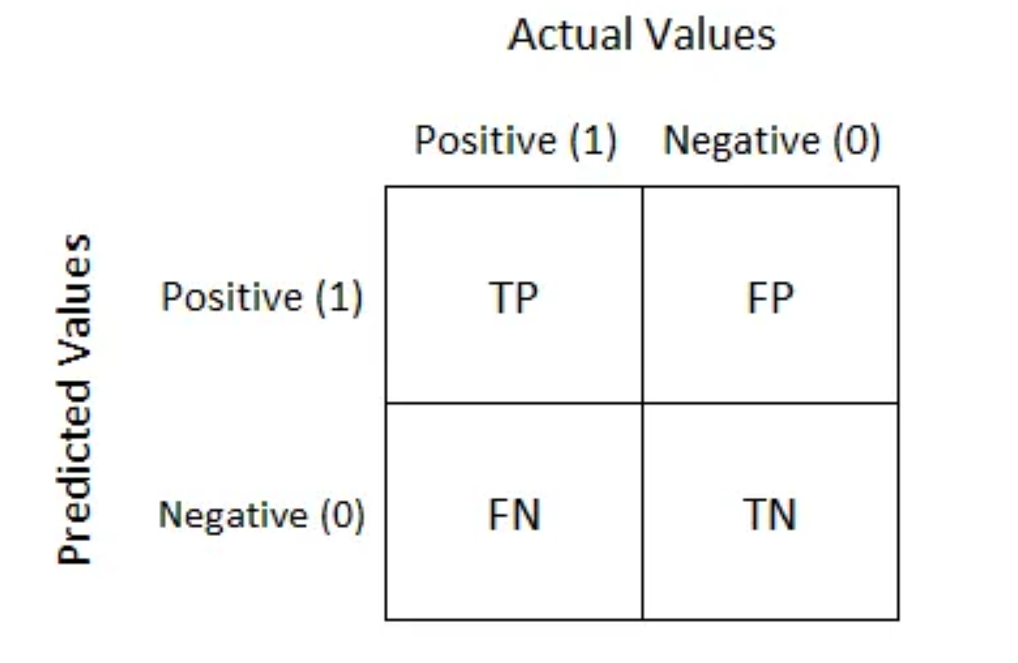
Figure 3.5: Example of confusion matrix (Narkhede, 2022).
- True Positive (TP): Instances where the model correctly predicted the positive class.
- True Negative (TN): Instances where the model correctly predicted the negative class.
- False Positive (FP): Instances where the model incorrectly predicted the positive class (actually negative).
- False Negative (FN): Instances where the model incorrectly predicted the negative class (actually positive).
- Area Under the ROC Curve (AUC-ROC): AUC-ROC is a metric for binary classification problems that measures the model's ability to distinguish between positive and negative classes (Narkhede, 2022).
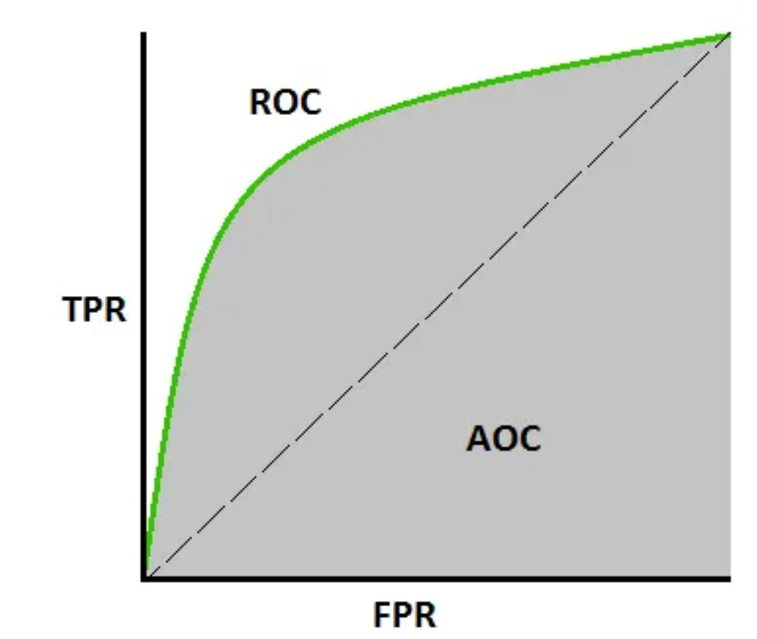
Figure 3.6: Area Under the ROC curve (Narkhede, 2022).
Figure 3.6 is the graphical representation of the Area Under the ROC curve.
- True Positive Rate: This is the rate of true positives. The formula for calculating the true positive rate is True Positives / (True Positives + False Negatives)
- False Positive Rate is the rate of false positives. The formula for calculating the false positive rates is False Positives / (True Negatives + False positives)
A model that has an AUC near 1 means it is good at classifying positives and negatives while a poor model has an AUC near 0 which means it is bad at classifying positives and negatives (Narkhede, 2022).

  - Tools and Software
- Programming Language: Python programming language will be used for building the model. Machine Learning Libraries like Sci-kit Learn, Pandas for data manipulation and analysis, Matplotlib used for visualizing the data.
- Jupyter Notebooks and JupyterLab is a web-based interactive development environment and text editor that allows users to write and execute Python code in cells within a notebook. This will be the text editor used to create the model.
- NSL-KDD dataset: This is the datasets that will be used for building the model.
The NSL-KDD dataset is a benchmark dataset used in the field of network intrusion detection using machine learning for evaluating the performance of algorithms in detecting network intrusions. It includes features such as protocol type, service, source and destination addresses, flags, and duration etc. The dataset contains different attack types, including denial-of-service (DoS), probe, user-to-root (U2R), and remote-to-local (R2L) attacks. The dataset comprises of the training and testing dataset which has 125973 rows, 42 columns and 22543 rows, 42 columns respectively (Choudhary & Kesswani, 2020).
The project findings will be presented with the use of tables and graphs. This will be generated using the matplotlib and seaborn library.

  - Modelling Stages
The stages involved in the development of the machine learning based intrusion detection system are:
- Importing the libraries and the NSL-KDD dataset.
- Carrying out data cleaning and manipulation.
- Relabeling of the multiple labels to binary labels.
- Separating Features (X) And Target Labels (Y) For Training and Testing dataset
- Data preprocessing which involves Label encoding, feature selection using Recursive Feature Elimination and Feature scaling using Standard scaler.
- Train test split the data into 70% for training and 30% for testing.
- Handling class imbalance in the training dataset
- Building the model using the three algorithms which is the Decision trees, Support Vector Machine and K-nearest neighbors.
- Training and testing
- Evaluation of the performance of the model.

CHAPTER 4
RESULTS AND DISCUSSION
  - Modelling
The implementation of a machine learning-based network intrusion detection system using the NSL-KDD dataset (refer to figures 4.2 and 4.3). Three models are used in this project: decision trees, support vector machines, and K-nearest neighbors. The best performing model will be chosen based on the results obtained from the testing phase.
    - Importing the Dataset
The NSL-KDD dataset consist of both the training and testing dataset.
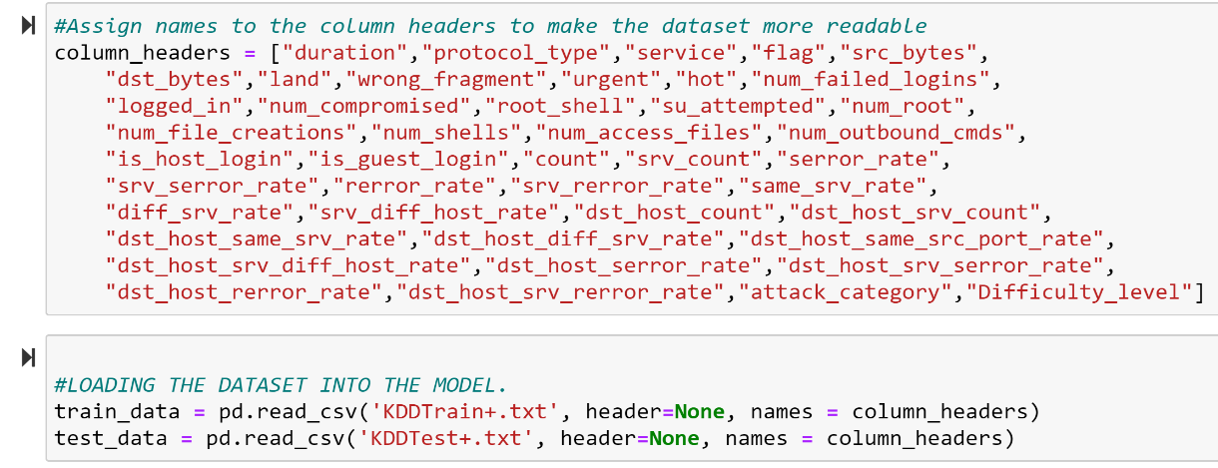
Figure 4.1: Loading the dataset.
Figure 4.1 loads the training and testing dataset using the Pandas library function called read_csv, and assigning column headers saved in the column_headers variable to the datasets in order to make the datasets more readable.
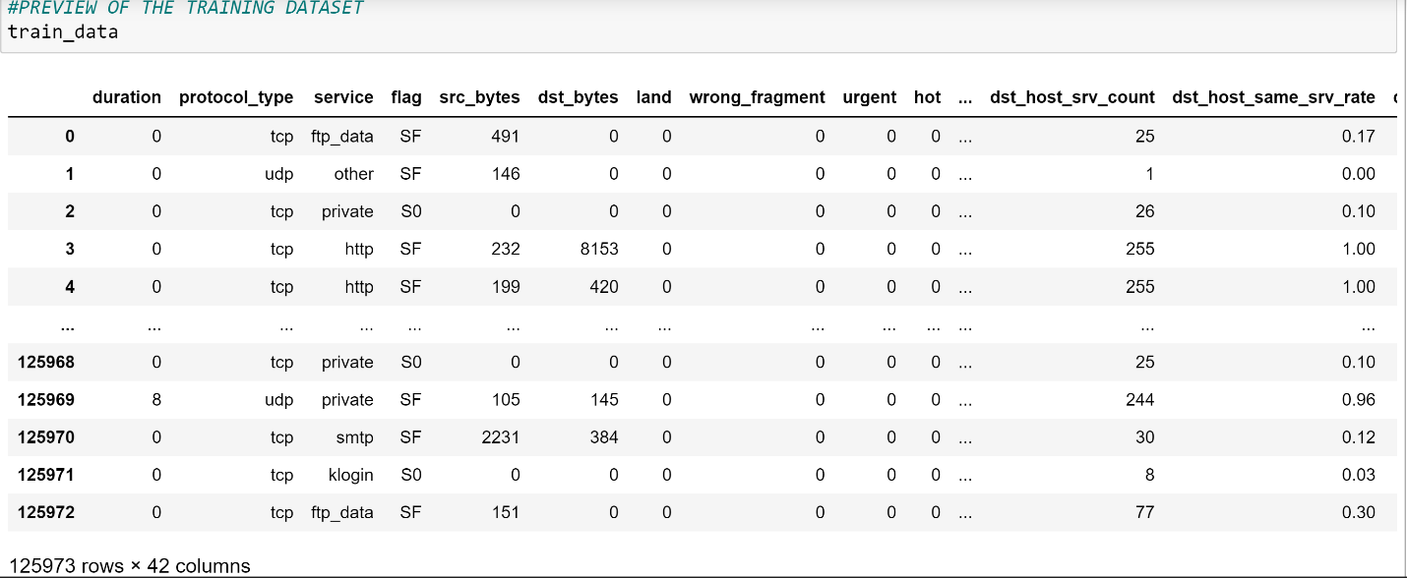
Figure 4.2: Preview of the NSL-KDD training dataset
The NSL-KDD training dataset consist of 125973 rows and 42 columns.
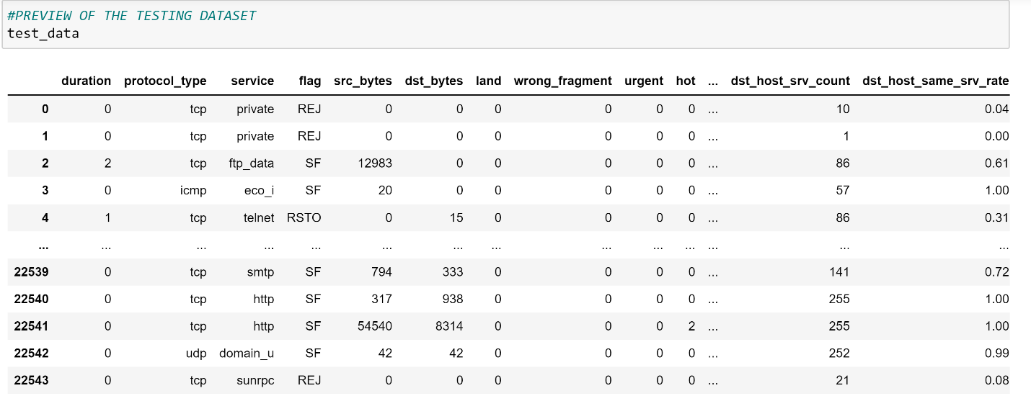
Figure 4.3: Preview of the NSL-KDD testing dataset
The NSL-KDD testing dataset consist of 22543 rows and 42 columns.
    - Data Cleaning and Manipulation
This stage focuses on data cleaning, removing unnecessary columns and null or NaN values that could impact the model's performance.
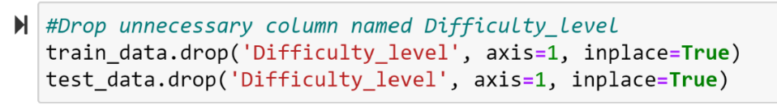
Figure 4.4: Dropping Unnecessary columns
Figure 4.4 shows how the Difficulty_level column was removed from the train and test dataset using the Pandas library drop method because it is not relevant and may affect the model’s performance.
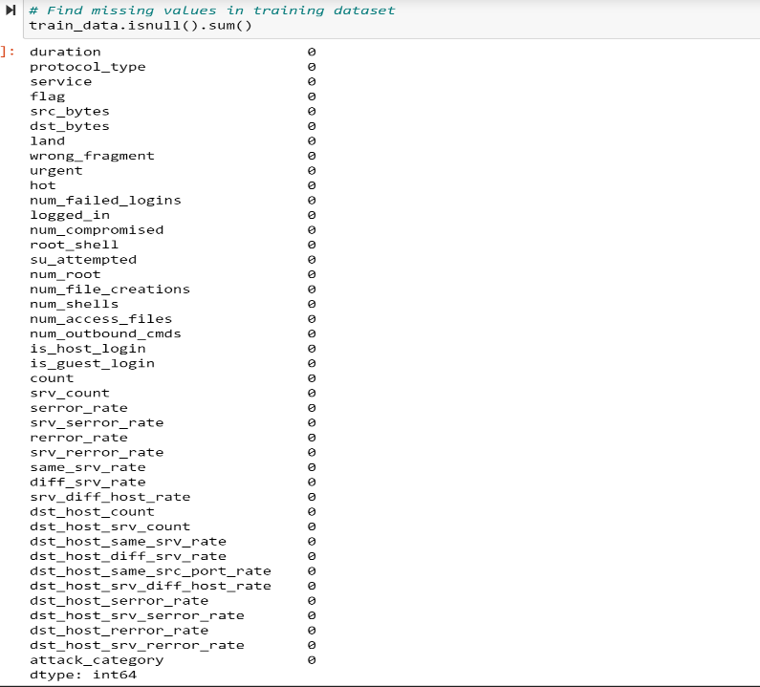
Figure 4.5: Check Null Values
Figure 4.5 shows how the isnull() pandas function helps to find null or missing values and the sum() helps to count the number of null values present in each of the columns. After the code is ran, the output shows no null values in the dataset which means the dataset is ready.
    - Relabeling Multiple Sub-labels to Binary Labels
Relabeling the Label column called attack_category to binary classification. All the attack labels were named “attack” and any other label that is not an attack is called “normal”.
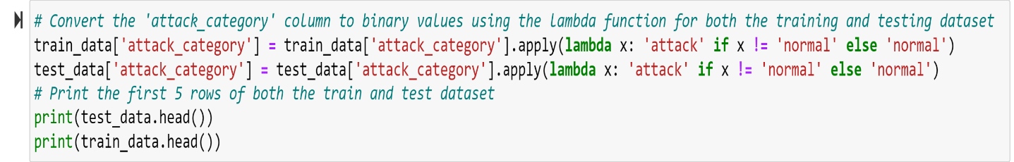
Figure 4.6: Label column to Binary classification
Figure 4.6 relabels the attack_category column of the training and testing dataset to either attack or normal as the label using the apply function with the lambda method. This is done because it helps the model to know the difference between good/normal traffic.
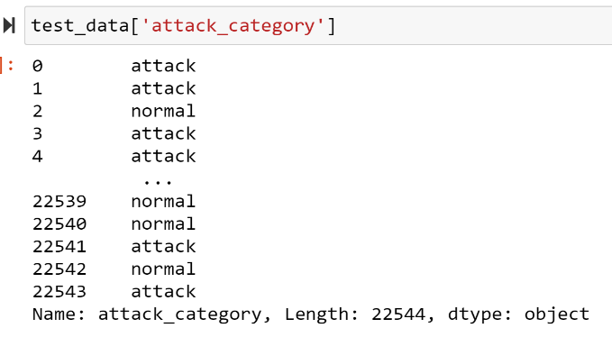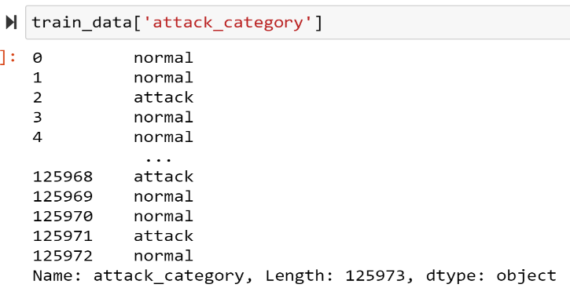
Figure 4.7: Preview of the attack_category column for both the training and testing dataset
Figure 4.7 shows the attack_category column for both training and testing dataset in order to see the new labels which is either “attack” and “normal”.
    - Percentage distribution of the labels in both training and testing datasets
Pie charts representing the percentage distribution of the two labels in both the training and testing datasets.
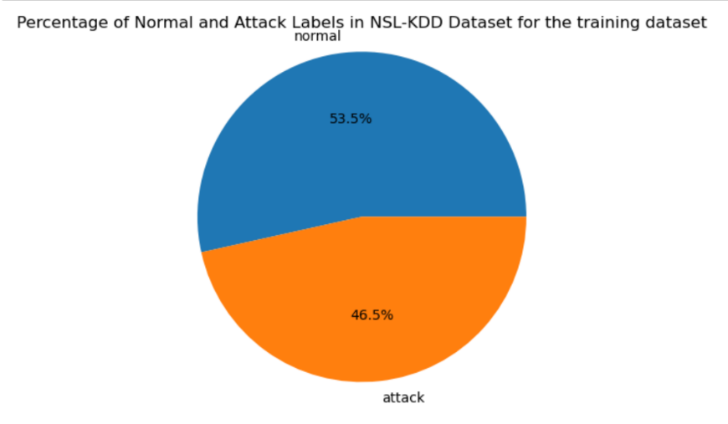
Figure 4.8: Percentage of Normal and Attack Labels in the NSL-KDD training dataset.
Figure 4.8 shows the percentage distribution between the two labels within the training dataset. The normal label is 53.5% while the attack label is 46.5%.
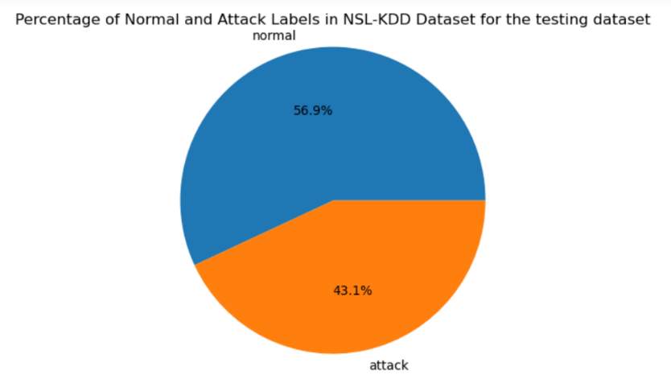
Figure 4.9: Percentage of Normal and Attack Labels in the NSL-KDD testing dataset.
Figure 4.9 shows the percentage distribution between the two labels within the testing dataset. The normal label is 56.9% and the attack label is 43.1%.
    - Label Encoding of the Training and Testing dataset
Label encoding converts all object or string characters in each column to its own unique numerical values which helps the model to understand the data more.
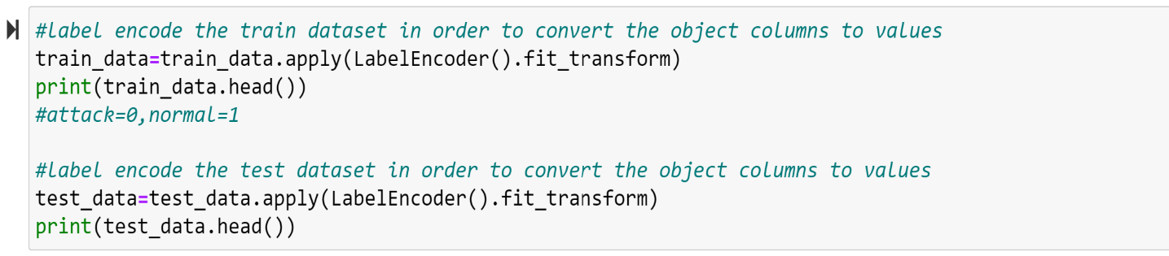
Figure 4.10: Encoding training and testing dataset.
Figure 4.10 above uses the apply function with the LabelEncoder class from the scikit-learn library. Label encoding is a technique used to transform text data (e.g., the service_type column or the attack_category column) into numerical data that computers can understand more. By calling the LabelEncoder class, it learns the categories in each text or object column and then replaces the categories with numerical values.
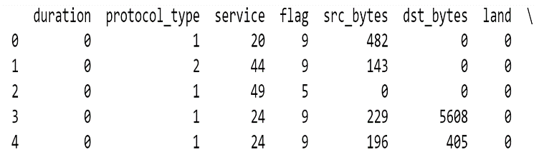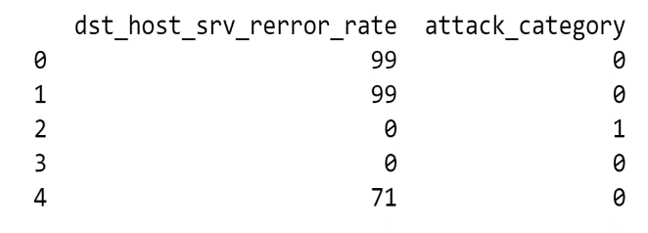
Figure 4.11: Preview of the encoded data.
Figure 4.11 shows the protocol_type, service, flag and attack_category columns that transformed to numerical values for each unique category. 0 represents attack while 1 represents normal.
    - Separating Features (X) And Target Labels (Y) For Training and Testing
This stage involves splitting the training and testing data into features (X) and labels (Y) for training and testing of the models.
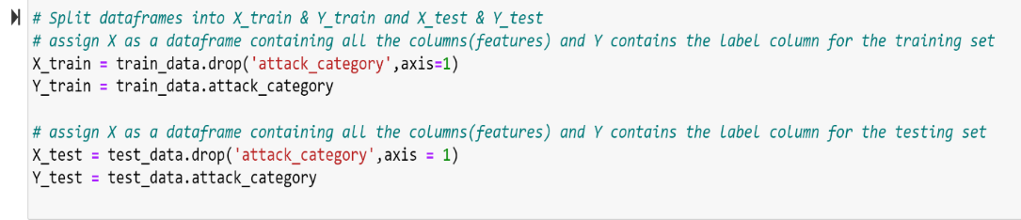
Figure 4.12: Splitting the features and target labels in both the training and testing dataset.
Figure 4.12 shows the separating of the training and testing datasets from train_data and test_data. The X_train and X_test represent the features without the label column (“attack_category”). These are what the model will learn in order to be able to detect malicious traffic. The Y_train and Y_test represent the target labels, these dataframes only contain the (“attack_category”) from the train and test dataset and this will help the model to detect malicious traffic based on the features in X_train and X_test.
    - Feature Selection Using Recursive Feature Elimination
Recursive feature elimination selection technique identifies the best features that can be used to train the model. This technique orders the features from most important to the least, then removes the least important features from the dataset and then repeats the process 2-4 times (Jeon & Oh, 2020). The recursive feature selection technique was used because it reduces the model’s complexity which leads to faster training time for the models.
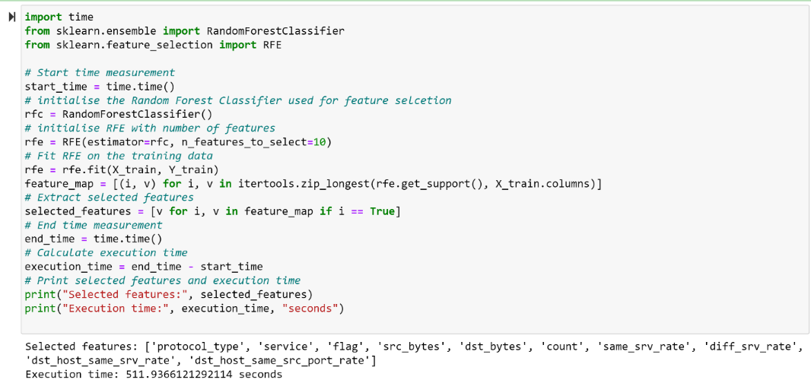
Figure 4.13: Python code for Feature selection using recursive feature selection on training data.
Figure 4.13 shows the code that uses the Recursive Feature Elimination with a random forest classifier to select the top ten features. It starts by calculating the execution time and then initializing the Random Forest Classifier. The RFE class is initialized with the random forest classifier and then sets the number of features to select to 10. The RFE object is then fit on the training data and the RFE object repeatedly trains the Random Forest classifier, identifying and removing the least important features based on how they contribute to network attack detection. After which it then extracts the features that are the most important. Finally, it prints the selected features and the execution time. The top ten features selected by the Recursive Feature Elimination technique include: protocol_type, service, flag, src_bytes, dst_bytes, count, same_srv_rate, diff_srv_rate ,dst_host_same_srv_rate and dst_host_same_src_port_rate. The execution time for this feature selection technique is 512 seconds.
    - Feature Scaling Using Standard Scaler
Feature scaling helps to transform values of features in the datasets to a specific range. It ensures the selected features contribute equally to the models training process.
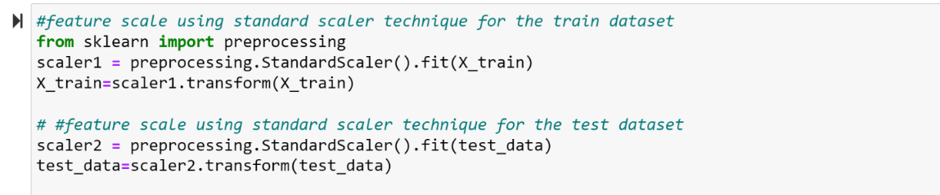
Figure 4.14: Python code to scale the dataset.
Figure 4.14 imports the preprocesssing module that contains the StandardScaler class which is the technique that will be used for this model. After importing the module, an object is created for the StandardScaler class. The object is then fit on the X_train that contains the top selected features and then transforms the data and same goes for the test data. For this project, the standard scalar feature scaling technique was used because it helps models’ performance.
    - Train Test Split
This is splitting the training set (X_train, Y_train) into 70% and 30% which is 70% for training and 30% for testing on the training dataset.
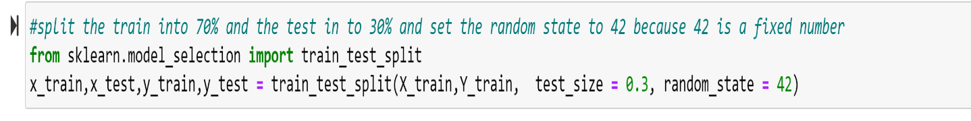
Figure 4.15: Train Test Split the training dataset.
Figure 4.15 uses the train_test_split class from the sklearn library in order to split the training dataset into 70% for training and 30% for testing and storing in the dataframes named x_train, x_test, y_train and y_test. The random state is set to 42 because it’s a fixed number.

    - Handling Class Imbalance
The final stage of building the model involves handling the class imbalance in order to help the models performance. The Synthetic Minority Over-Sampling Technique (SMOTE) is used to handle the class imbalance in the training dataset (y_train). This technique is used because of how it handles high dimensional dataset.
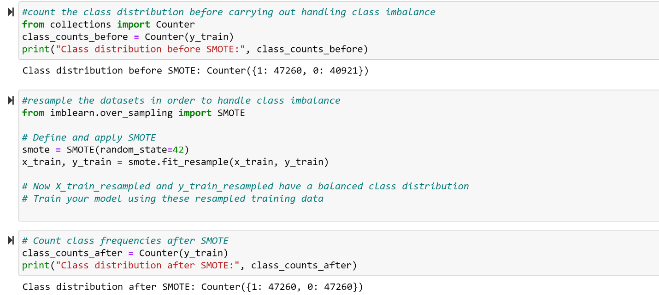
Figure 4.16: Code to handle class imbalance
In figure 4.16, a counter is set at the beginning in order to know the distribution of the class before the use of the SMOTE technique. The class distribution before SMOTE is (1: 47260, 0: 40921) which shows an imbalance in the dataset which needs to be addressed. The second cell imports the SMOTE class from the imblearn library, an object is initialized to the SMOTE class which is then fit on the x_train and y_train. Then finally, a counter at the end shows the class distribution after using the SMOTE technique to handle class imbalance. The class distribution after SMOTE is (1: 47260, 0: 47260).
    - Decision Tree Model
In this section, the decision tree classifier is trained using the x_train, y_train data and the execution time is measured.
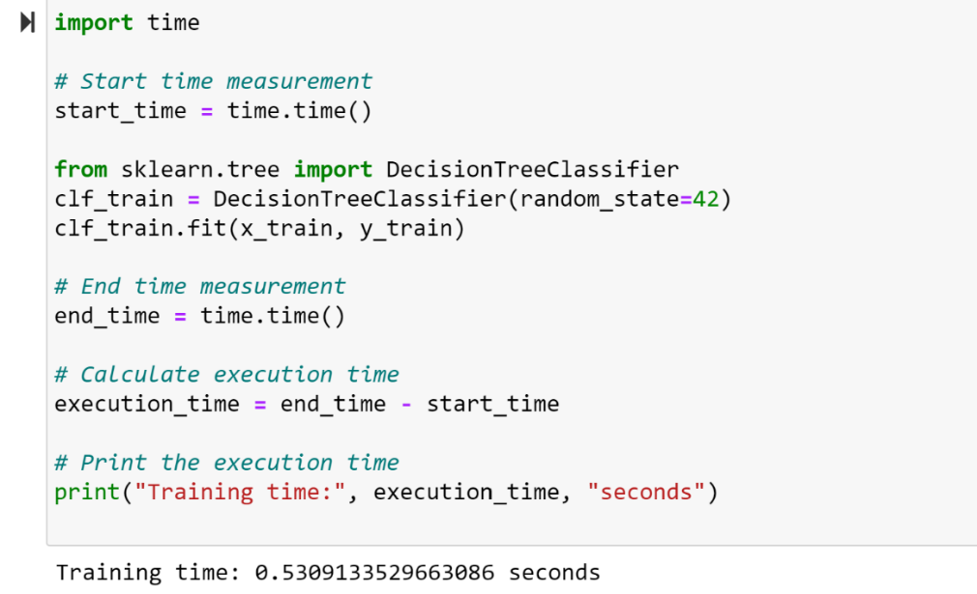
Figure 4.17: Training the Decision Tree model.
Figure 4.17 starts by importing the time library in which the execution time is measured in other to know the training time of the model. During which the DecisionTreeClassifier is imported and then an object is created which fits the training dataset (x_train, y_train). The training time for the Decision Tree model is 0.53 seconds and testing time is 0.018 nanoseconds.

    - Support Vector Machine
In this section, the Support Vector Machine is trained using x_train, y_train and the execution time is measured.
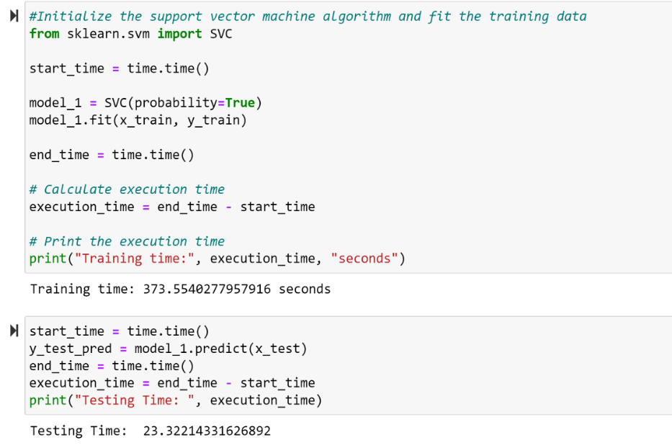
Figure 4.18: Training the Support Vector Machine model
Figure 4.18 shows the training of the Support Vector Machine model by fitting the x_train and y_train dataframe. The time module is imported and is used for measuring the training time of the model. The training time for the Support Vector Machine is 373.6 seconds while the testing time of the model is 23 seconds.
    - K-Nearest Neighbors
The K-nearest Neighbors model is trained on the x_train and y_train dataframes in which the execution time is measured. In this project, the newly introduced optuna library is used for the hyperparameter optimization of the KNN algorithm. The optuna library does this by automating the process of searching for the right values. Using an optimization technique can impact model’s performance in a positive way.
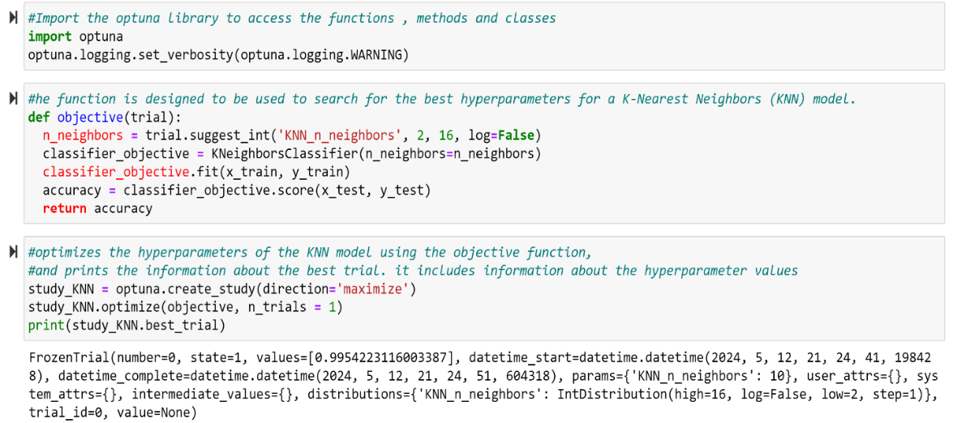
Figure 4.19: Optuna library
In figure 4.19 the optuna hyperparameter optimization library is imported. The second cell is a function called objective that is created to search for the best hyperparameter values for the KNN model. This is done by suggesting different hyperparameter values for the n_neighbors parameter (number of neighbors considered for prediction) within a range (Akiba et al., 2019). For each value, it creates a KNN model, trains it on x_train and y_train, and evaluates its performance using accuracy on the testing data. Finally, it returns the score back to Optuna. Then Optuna iterates different n_neighbors values, train several KNN models, and finally find the configuration that gives the best accuracy on the testing data. The third cell creates study_KNN used initialize and maximize the accuracy. It then runs the objective function (defined earlier) evaluating a set of hyperparameters for the KNN model. Finally, it prints the details of this single trial which then includes the n_neighbors value, accuracy and other information. This output of the code above represents a single trial (number 0) done by Optuna during the hyperparameter search for your KNN model. The trial ran for 10 seconds and KNN_n_neighbors was set to 10. The accuracy is 99%.
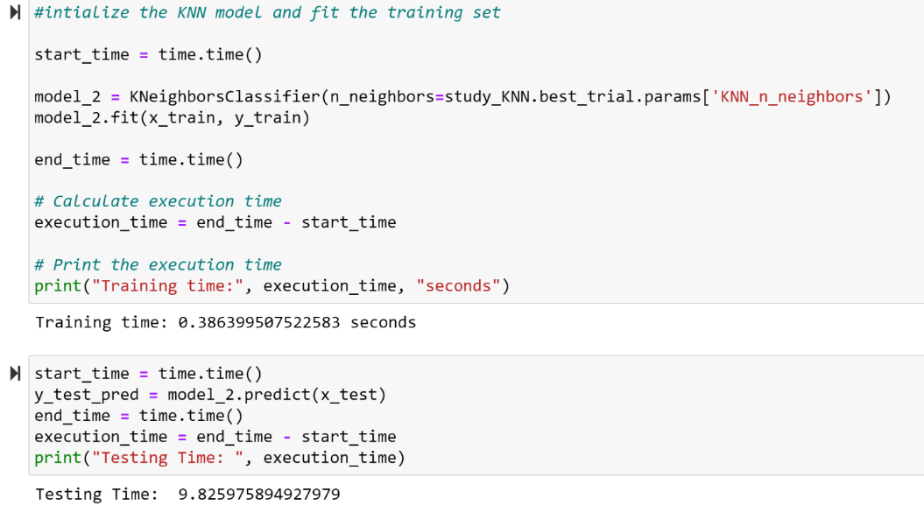
Figure 4.20: Training the KNN model
Figure 4.20 shows the training of the K-Nearest Neighbors model by fitting the x_train and y_train dataframe. The time module is imported and is used for measuring the training time of the model. The training time for the K-nearest Neighbors is 0.386 seconds while the testing time of the model is 9 seconds.
  - Results of each of the model
The evaluation metrics that will be used to assess the performance of each of model. These metrics include training time, testing time, accuracy, precision, recall, F1-score, AUC-ROC curve, AUC score, confusion matrix.
Table 4.1: Comparison of training and testing time for each of the algorithm
Algorithms | Training Time | Testing Time
Decision Trees | 0.53 milliseconds | 0.014 nanoseconds
Support Vector Machine | 373 seconds | 23 seconds
K-nearest Neighbors | 0.39 milliseconds | 9.8 seconds

As shown in table 4.1, the training time of the decision tree algorithm is 0.53 milliseconds, support vector machine is 373 seconds and the K-nearest neighbors is 0.39 milliseconds. The testing time of the decision tree algorithm is 0.014 milliseconds, support vector machine is 23 seconds and the K-nearest Neighbors is 9.8 seconds. Therefore, the model with the fastest time is the Decision trees model. Although, the K-nearest neighbors had the fastest training time but the testing time was more than Decision trees.

Table 4.2: Comparison of the training and testing accuracy for the three algorithms
Algorithms | Training Accuracy (%) | Testing Accuracy (%)
Decision Trees | 0.999 | 0.997
Support Vector Machine | 0.989 | 0.987
K-Nearest Neighbors | 0.996 | 0.995

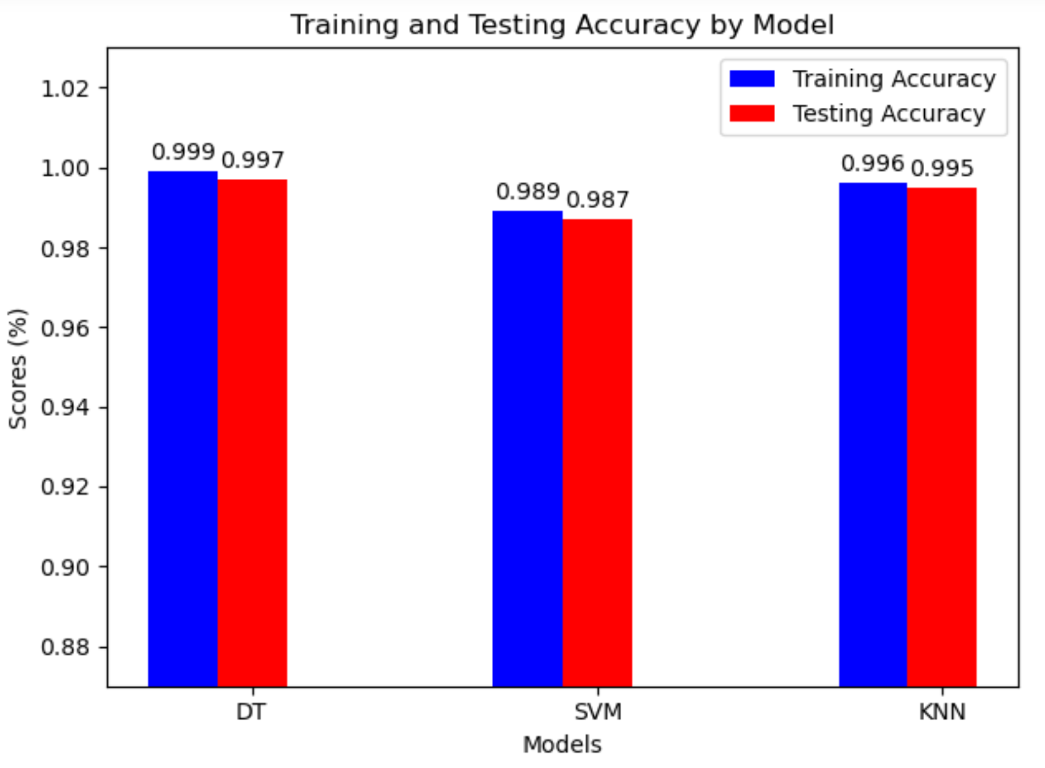
Figure 4.21: A comparison of the training and testing accuracy of each of the algorithms
As shown in figure 4.21 and table 4.2, all the three algorithms used in this project achieved high accuracy in both training and testing with a very slight difference across the different models. The decision tree model achieved the training and testing accuracy score of 0.999 and 0.997 respectively which outperformed the K-nearest neighbors which got an accuracy of 0.996 and 0.995. The Support Vector Machine model got an accuracy of 0.989 and 0.987 which performed the lowest among the three models. Therefore, the Decision tree model got the best accuracy for both training and testing followed by the K-nearest neighbors and then the Support Vector Machine model.
Table 4.3: Comparison of performance metrics on the normal label for the three models.
Algorithms | Precision (%) | Recall (%) | F1-score (%)
Decision Trees | 1.00 | 1.00 | 1.00
Support Vector Machine | 0.98 | 0.99 | 0.99
K-Nearest Neighbors | 0.99 | 1.00 | 1.00

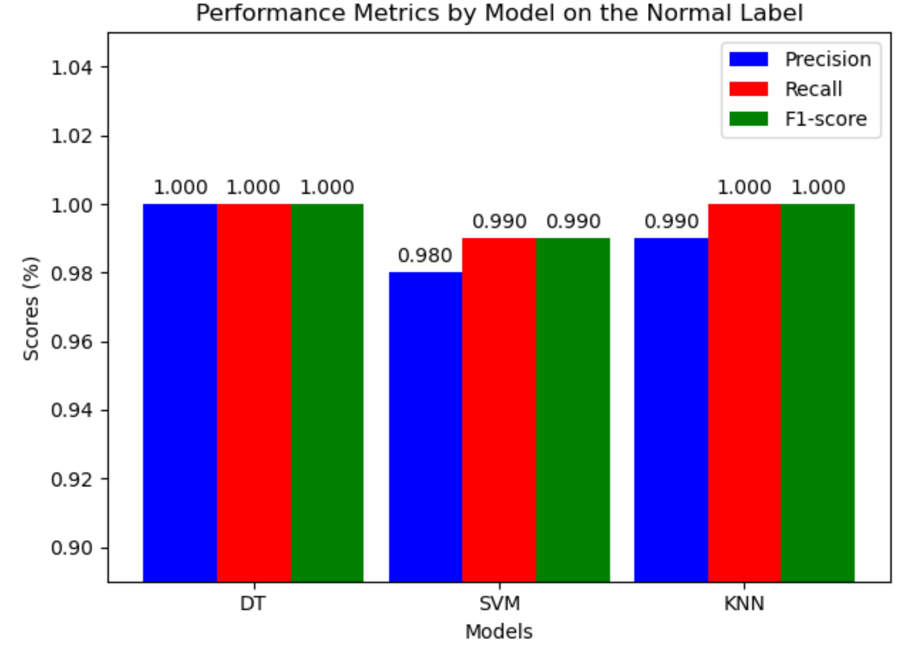
Figure 4.22: A comparison of the metrics on the normal label for each of the models.
Figure 4.22 and table 4.3 shows how well the Decision Tree, Support Vector Machine, and K-Nearest Neighbors models classify the normal label. All models score very high (close to 1.0) for precision, recall, and F1-score. Precision means the models were mostly right when predicting "normal," recall means they didn't miss many actual normal cases, and F1-score combines the two metrics. While all models performed very well, the Decision tree model performed the best amongst the three models with a perfect score in each of the metrics.
Table 4.4: Comparison of performance metrics on the attack label for the three models.
Algorithms | Precision (%) | Recall (%) | F1-score (%)
Decision Trees | 1.00 | 1.00 | 1.00
Support Vector Machine | 0.99 | 0.99 | 0.99
K-Nearest Neighbors | 1.00 | 1.00 | 1.00
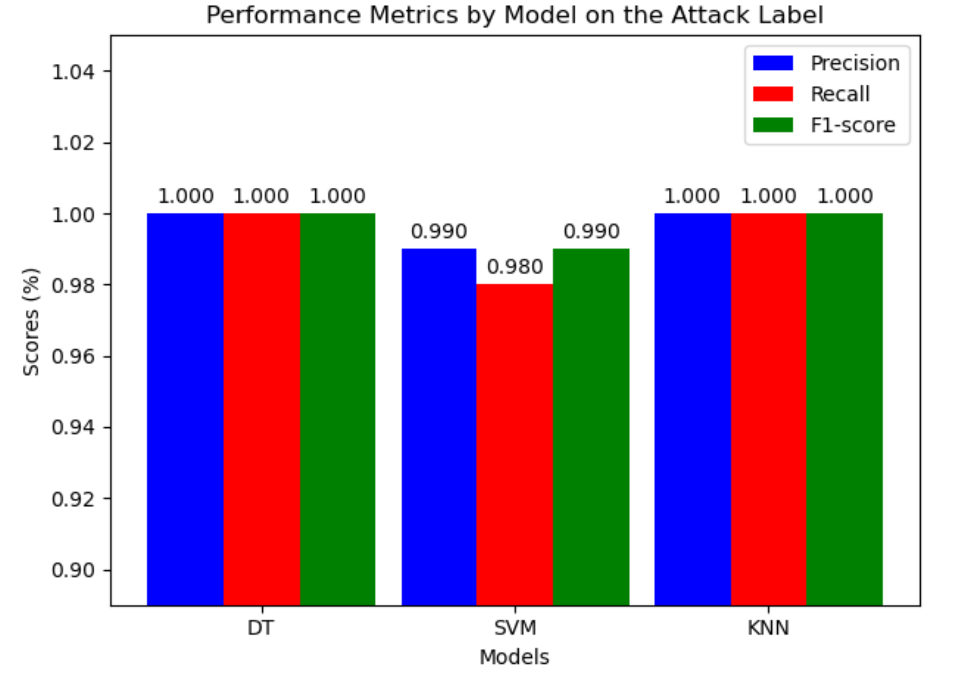
Figure 4.23: A comparison of the metrics on the attack label for each of the models.
Figure 4.23 and table 4.4 shows how well the Decision Tree, Support Vector Machine, and K-Nearest Neighbors models classify the attack label. All models score very high (close to 1.0) for precision, recall, and F1-score. Precision means the models were mostly right when predicting "attack”, recall means they didn't miss many actual normal cases, and F1-score combines the two metrics. While all models performed very well, the Decision tree and K-nearest neighbors model had the same score of 100% in each of the performance metrics.
Table 4.5: Comparison of the AUC score of each model
Algorithms | AUC score (%)
Decision Trees | 0.997
Support Vector Machine | 0.988
K-nearest neighbors | 0.995
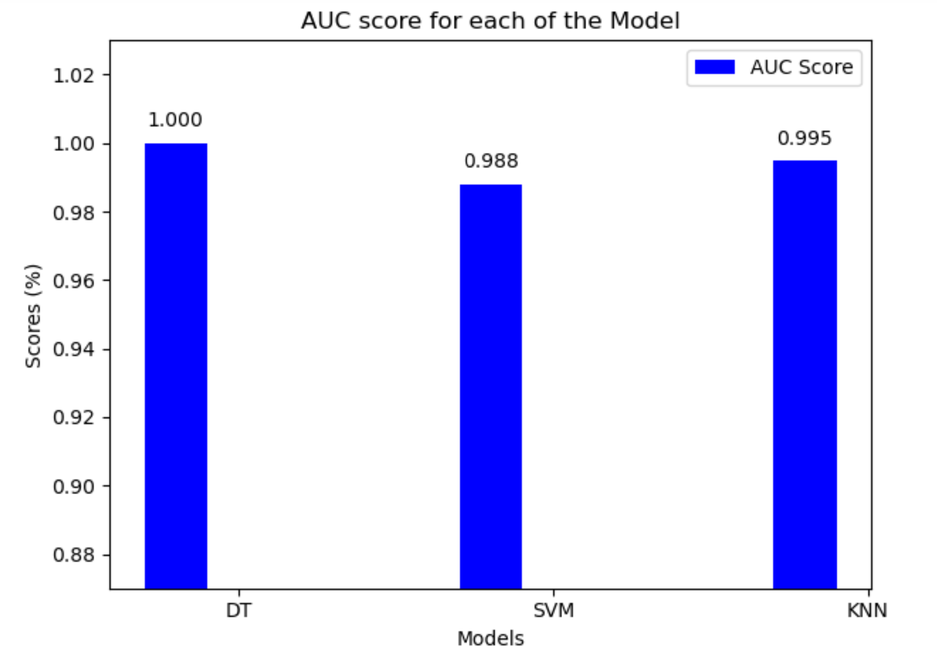
Figure 4.24: A graphical representation of the AUC score for each of the models.
As shown in figure 4.24 and table 4.5, all the three algorithms used in this project achieved high AUC (Area under the ROC Curve) score with a very small difference across the different models. The decision tree model achieved the best AUC score which is 1.00 which surpassed the K-nearest neighbor which had an AUC score of 0.995 and the Support Vector Machine had an AUC score of 0.988.
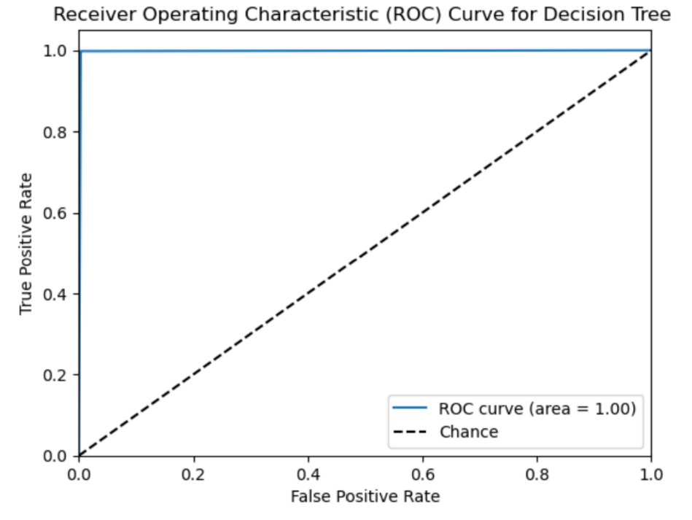
Figure 4.25: AUC-ROC curve for Decision tree model.
The ROC curve displayed in figure 4.25 shows the performance of the Decision Tree model, showing its ability to classify normal and attack classes. The curve is a vertical line from (0,0) to (0,1) and then a horizontal line from (0,1) to (1,1), this shows the model performed really well with a true positive rate (TPR) of 1 and a false positive rate (FPR) of 0. Also, the Area Under the Curve (AUC) value of 1.00 further confirms the model makes no errors in classification.
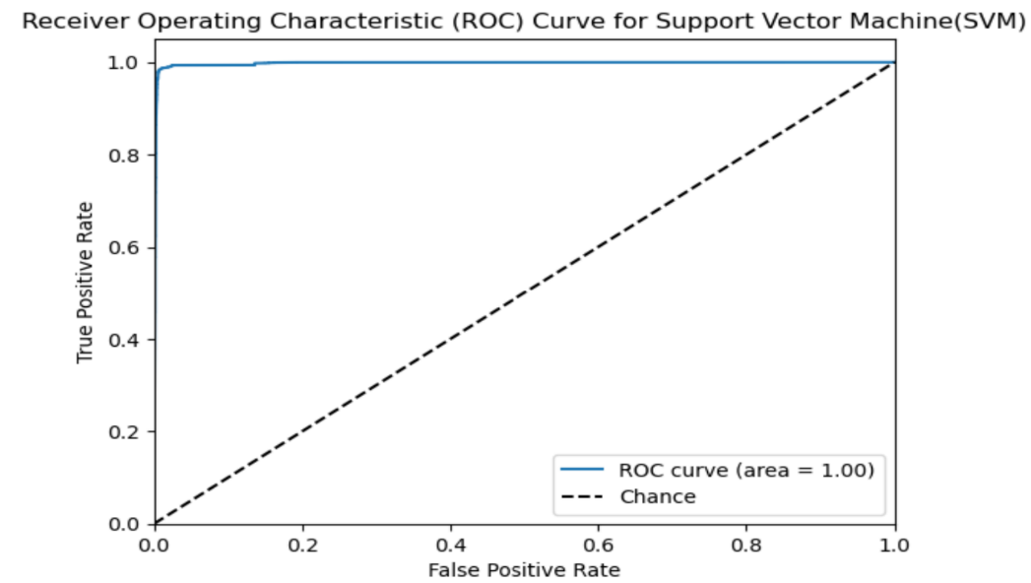
Figure 4.26: AUC-ROC curve for Support Vector Machine
The ROC curve in figure 4.26 represents the AUC-ROC curve of the support vector machine model. From above you can notice the slight deviation from 1.0 which shows its not that perfect but it performed well because it can still classify normal and attack labels. The Area under the curve is 1.00 which shows the model is performing well.
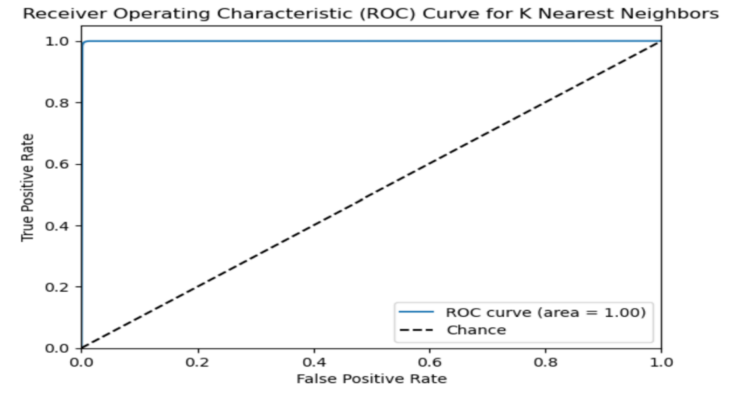
Figure 4.27: AUC-ROC curve for K-nearest neighbors model.
Figure 4.27 represents the AUC-ROC curve of the K-nearest neighbors, from above you can notice the slight deviation from 1.0 which shows it’s not as perfect as the decision tree model but it performed well because it can still classify normal and attack labels. The Area under the curve is 1.00 which shows the model is performing well.
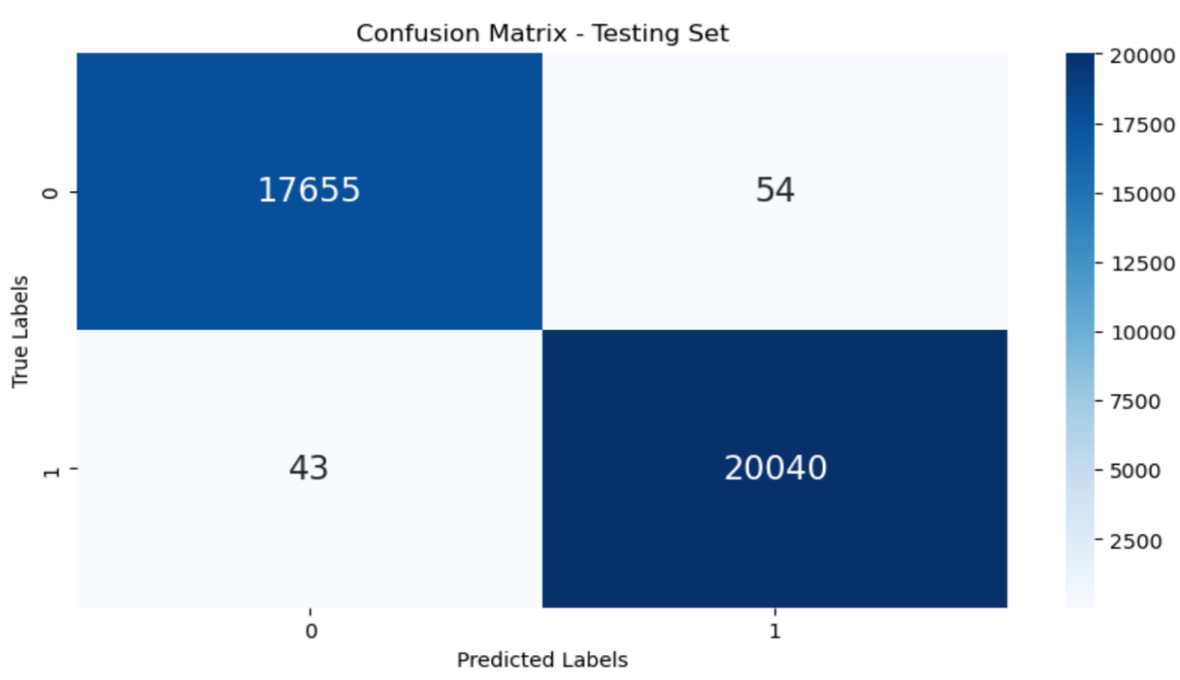
Figure 4.28: Confusion Matrix of the Decision Trees
Figure 4.28 shows the confusion matrix for the Decision tree model. The labels 0 and 1 represent attack and normal states, respectively. The confusion matrix for the testing set got 17655 true negatives (correctly identified attacks) and 20040 true positives (correctly identified normal states). There are 54 false positives (a normal state incorrectly identified as an attack) and 43 false negatives (an attack incorrectly identified as a normal state).
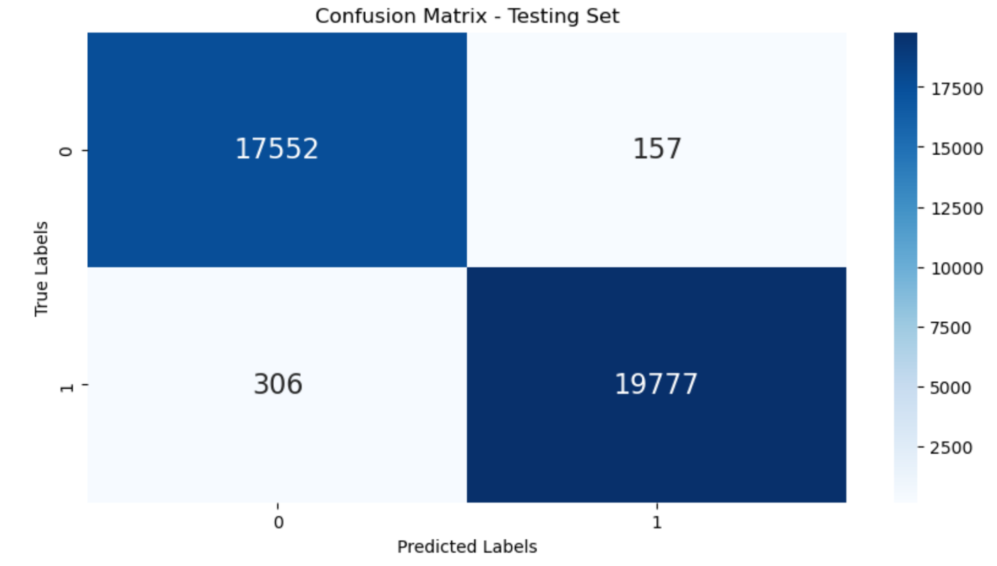
Figure 4.29: Confusion Matrix of the Support Vector Machine model on Testing.
From figure 4.29, The confusion matrix for the testing set got 17552 true negatives (correctly identified attacks) and 19777 true positives (correctly identified normal states). There is 157 false positives (a normal state incorrectly identified as an attack) and 306 false negatives(an attack incorrectly identified as a normal state). The Support Vector Machine performed extremely well but didn’t outperform the decision tree model.

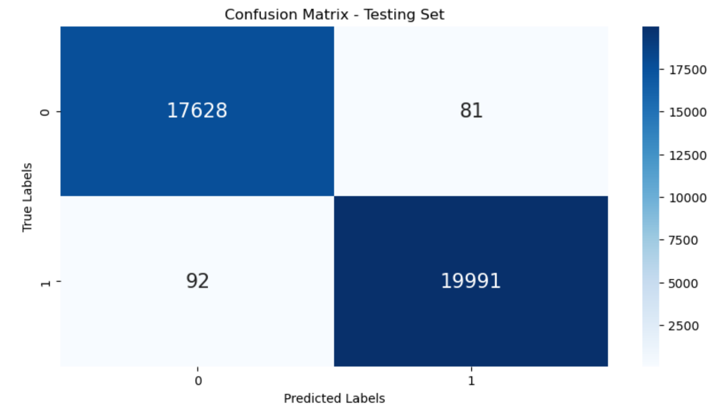
Figure 4.30: Confusion Matrix of the K-nearest neighbors model on Testing.
From figure 4.30, The confusion matrix for the testing set got 17628 true negatives (correctly identified attacks) and 19991 true positives (correctly identified normal states). There is 81 false positives (a normal state incorrectly identified as an attack) and 92 false negatives (an attack incorrectly identified as a normal state). The K-nearest neighbors performed extremely well but didn’t outperform the decision tree model.

  - Comparison with past works
To further validate findings from this project, results of previous studies are compared with this project. The use of evaluation metrics such as accuracy, precision, recall, f1-score, AUC score, confusion metrics and AUC-ROC curve which is in line with the objectives of this project. The results of this project show that machine learning can improve the security posture of a network.
Table 4.6: Comparison of results with previous studies
Authors | Method | Accuracy (%)
Ahmed et al. (2022) | Random Forest, Decision Tree, Logistic Regression, K-Nearest Neighbors and Artificial Neural Networks. | 89.29
Abdallah et al. (2022) | Using Supervised learning techniques | 94.00
Rohit et al. (2018) | Correlation method to perform feature selection and use of an ensemble approach combining three algorithms: Naïve Bayes, PART, and Adaptive Boost. | 92.97
This Project | Recursive Feature Elimination for feature selection, Standard Scaler for feature scaling, Label Encoding, Optuna for hyper parameter optimization and three algorithms (K-nearest neighbors, Decision Tree, Support Vector Machine) | 99.99
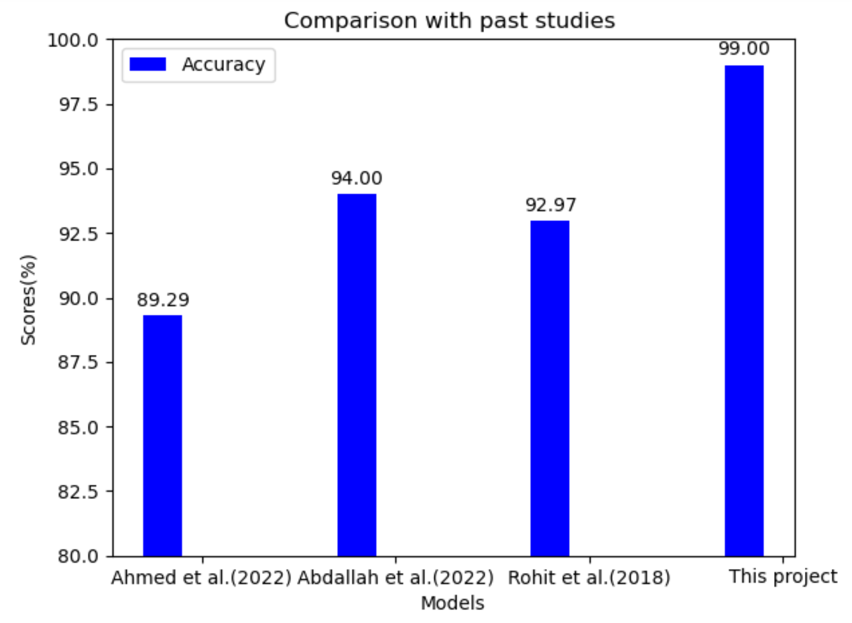
Figure 4.31: Comparison of results with previous Studies
Figure 4.31 is a graphical illustration of the difference in accuracy with previous studies. Works by Ahmed et al. (2022), the author made use of five algorithms which achieved only 89.29% accuracy as shown figure 48 and had class imbalance issues where as my model achieved 99% accuracy as shown in figure 48 and I handled the class imbalance with the use of the SMOTE technique. Abdallah et al. (2022) made use of the decision tree algorithm and feature selection but got an accuracy of 94% while my model achieved 99% accuracy with the use of recursive feature elimination technique. An ensemble approach comprising of Naïve Bayes, PART, Adaptive Boost by Rohit et al. (2018) used the correlation-based feature selection method for feature selection and obtained an accuracy of 92.97% with a longer training time while I used the recursive feature selection method which achieved 99% accuracy with shorter training time.
CHAPTER 5
SUMMARY, CONCLUSION AND RECOMMENDATION
  - Summary
The project aimed to Development Of A Network Intrusion Detection Model Using Machine Learning. This was done using Python programming language and multiple tools and software’s.
The NSL-KDD dataset is divided into the training and testing dataset, which the training dataset was split into 70% for training and 30% for testing. After training the dataset, the model is tested using the testing dataset. The use of jupyter notebook as the environment for running the model. The use of Recursive Feature Elimination for feature selection which picked the 10 best features in the dataset which is the protocol_type, service, flag, src_bytes, dst_bytes, count, same_srv_rate, diff_srv_rate, dst_host_same_srv_rate, dst_host_same_src_port_rate, Standard Scaling method for feature scaling, SMOTE technique for handling class imbalance and Optuna for hyperparameter optimization of the K-nearest neighbors algorithm. The three algorithms used for this project is the Decision tree, Support Vector Machine and K-nearest neighbors algorithm. During training, evaluation metrics such as accuracy, recall, precision, f1-score, confusion matrix and AUC-ROC curve were used to assess the performance of the model. The implementation of the model was successful, achieving the aim of accurately detecting malicious activities on the network. Screenshots of the code was taken at every stage of the implementation.
  - Recommendations
Based on the evaluation of the project, here is a few recommendations that can enhance the field of the network security using machine learning:
- Implementation of user interface program that sends email alert notification on any attack detection.
- Training Machine learning models can need high computation resource. In order to improve the training and testing, it is advisable to train the model on cloud-based application such google colab which doesn’t use the system’s resources.
- Use of a larger dataset in order to improve the model’s ability to detect attacks more accurately and efficiently.
  - Conclusion
In conclusion, machine learning can be used to effectively and efficiently detect network intrusions accurately. This project also proved that despite limited computing resources, high accuracy values can be obtained. The project involved the use of Python programming language, the NSL-KDD dataset consisting of 125973 rows and 42 columns, 22544 rows and 42 columns in the training and testing dataset respectively. The three models are the decision tree, support vector machine and K-nearest neighbors. Each model’s performance was assessed using evaluation metrics such as accuracy, precision, recall, f1-score, AUC score, AUC-ROC curve and confusion matrix. The decision tree model got an accuracy of 99% on both training and testing, an AUC score of 99%, 100% precision, recall and f1-score on both labels (normal and attack). The Support Vector Machine got an accuracy of 98% on both training and testing, an AUC score of 98%, 98% precision, 98% recall and 98% f1-score on both labels (normal and attack). The K-nearest neighbors model got an accuracy of 99% on both training and testing, an AUC score of 99%, 100% precision, recall and f1-score on both labels (normal and attack). The decision tree model performed the best amongst the three models because of the low false positives present and the ROC curve is much closer to one which means its perfect in classifying normal and attack labels.

REFERENCES
Abdallah, E. E., Eleisah, W., & Otoom, A. F. (2022). Intrusion Detection Systems using Supervised Machine Learning Techniques: A survey. Procedia Computer Science, 201, 205–212. https://doi.org/10.1016/j.procs.2022.03.029
Abubakar, A., & Garko, A. B. (2021). A Predictive Model for Network Intrusion Detection System Using Deep Neural Network. Dutse J. Pure Appl. Sci.(DUJOPAS), 7(3a), 113-128. https://www.ajol.info/index.php/dujopas/article/view/219859
Ahmad, A., & Senga, B. P. S. (2017). Instruction Detection System based on Support Vector Machine using BAT Algorithm. International Journal of Computer Applications, 158(8), 27–30. https://doi.org/10.5120/ijca2017912843
Ahmad, Z., Khan, A. S., Shiang, C. W., Abdullah, J., & Ahmad, F. (2020). Network intrusion detection system: A systematic study of machine learning and deep learning approaches. Transactions on Emerging Telecommunications Technologies, 32(1). https://doi.org/10.1002/ett.4150
Ahmed, H. A., Hameed, A., & Bawany, N. Z. (2022). Network intrusion detection using oversampling technique and machine learning algorithms. PeerJ, 8, e820. https://doi.org/10.7717/peerj-cs.820
Akiba, T., Sano, S., Yanase, T., Ohta, T., & Koyama, M. (2019). Optuna. Optuna: A Next-generation Hyperparameter Optimization Framework. https://doi.org/10.1145/3292500.3330701
Almutairi, Y., Alhazmi, B., & Munshi, A. A. (2022). Network intrusion detection using machine learning techniques. Advances in Science and Technology Research Journal, 16(3), 193–206. https://doi.org/10.12913/22998624/149934
Ambika. (2023, August 19). Support Vector Machine (SVM) algorithm: Explained - ambika - medium. Medium. https://medium.com/@ambika199820/support-vector-machine-svm-algorithm-explained-c8facc10bcfa
Chauhan, N. S. (n.d.). Decision Tree algorithm, explained - KDnuggets. KDnuggets. https://www.kdnuggets.com/2020/01/decision-tree-algorithm-explained.html
Choudhary, S., & Kesswani, N. (2020). Analysis of KDD-Cup’99, NSL-KDD and UNSW-NB15 Datasets using Deep Learning in IoT. Procedia Computer Science, 167, 1561–1573. https://doi.org/10.1016/j.procs.2020.03.367
Chkadmin. (2023, September 7). What is an Intrusion Detection System (IDS)? Check Point Software. https://www.checkpoint.com/cyber-hub/network-security/what-is-an-intrusion-detection-system
Cisco (2023, July 4). Cisco. https://www.cisco.com/c/en/us/products/security/what-is-network-security.html
Coulibaly, K. (2020, April 19). An overview of Intrusion Detection and Prevention Systems. arXiv.org. https://arxiv.org/abs/2004.08967
Dini, P., Elhanashi, A., Begni, A., Saponara, S., Zheng, Q., & Gasmi, K. (2023). Overview on Intrusion Detection Systems Design Exploiting Machine Learning for Networking Cybersecurity. Applied Sciences, 13(13), 7507. https://doi.org/10.3390/app13137507
Gaborov, M., Karuović, D., Kavalic, M., Radosav, D., Milosavljev, D., Stanisaljev, S., & Bushati, J. (2021). Comparative analysis of agile and traditional methodologies in IT project management. 81.2.247.240. https://doi.org/10.24368/jates.v11i4.279
Gautam, R. K. S., & Doegar, E. A. (2018). An ensemble approach for intrusion detection system using machine learning algorithms. In 2018 8th International conference on cloud computing, data science & engineering (confluence) (pp. 14-15). https://ieeexplore.ieee.org/document/8765431
Gu, J., & Lu, S. (2021). An effective intrusion detection approach using SVM with naïve Bayes feature embedding. Computers & Security, 103, 102158. https://doi.org/10.1016/j.cose.2020.102158
Haripriya, L., & Jabbar, M. A. (2018). Role of Machine Learning in Intrusion Detection System: review. 2018 Second International Conference on Electronics, Communication and Aerospace Technology (ICECA). https://doi.org/10.1109/iceca.2018.8474576
Hashemi-Pour, C., & Chai, W. (2023, December 21). CIA triad (confidentiality, integrity and availability). WhatIs. https://www.techtarget.com/whatis/definition/Confidentiality-integrity-and-availability-CIA
Hu, L., Huang, M., Ke, S. W., & Tsai, C. (2016). The distance function effect on k-nearest neighbor classification for medical datasets. SpringerPlus, 5(1). https://doi.org/10.1186/s40064-016-2941-7
Hu, Y., Wang, Q., Wang, L., Zhang, P., Li, M., & Liu, Y. (2017). An intrusion detection framework based on hybrid Multi-Level data mining. International Journal of Parallel Programming, 47(4), 740–758. https://doi.org/10.1007/s10766-017-0537-7
Jackson, A. (2023, August 27). Zayo Group: 200% surge in DDoS attacks. Cyber Magazine. https://cybermagazine.com/cyber-security/zayo-group-confirms-ddos-attacks-in-2023-are-up-200
Jeon, H., & Oh, S. (2020). Hybrid-Recursive feature elimination for efficient feature selection. Applied Sciences, 10(9), 3211. https://doi.org/10.3390/app10093211
Kaur, J., & Ramkumar, K. R. (2022). The recent trends in cyber security: A review. Journal of King Saud University. Computer and Information Sciences/Maǧalaẗ Ǧamʼaẗ Al-malīk Saud : Ùlm Al-ḥasib Wa Al-maʼlumat, 34(8), 5766–5781. https://doi.org/10.1016/j.jksuci.2021.01.018
Ken, K. (2023, September 13). Cyber attack statistics (Updated January 2024) - Parachute. Parachute. https://parachute.cloud/cyber-attack-statistics-data-and-trends/
Khraisat, A., Gondal, I., Vamplew, P., & Kamruzzaman, J. (2019). Survey of intrusion detection systems: techniques, datasets and challenges. Cybersecurity, 2(1). https://doi.org/10.1186/s42400-019-0038-7
Liang, D., Liu, Q., Zhao, B., Zhu, Z., & Liu, D. (2019). A clustering-svm ensemble method for intrusion detection system. In 2019 8th International Symposium on Next Generation Electronics (ISNE) https://ieeexplore.ieee.org/document/8896514
Maithem, M., & Al-Sultany, G. A. (2021). Network intrusion detection system using deep neural networks. Journal of Physics, 1804(1), 012138. https://doi.org/10.1088/1742-6596/1804/1/012138
Mouli, K. C., Indupriya, B., Ushasree, D., Raghavendran, C. V., Rawat, B., & Madhu, B. (2023). Network Intrusion Detection using ML Techniques for Sustainable Information System. E3S Web of Conferences, 430, 01064. https://doi.org/10.1051/e3sconf/202343001064
N, T. R., & Gupta, R. (2021). Design and development of an efficient network intrusion detection system using machine learning techniques. Wireless Communications and Mobile Computing, 2021, 1–35. https://doi.org/10.1155/2021/9974270
Narkhede, S. (2021, June 15). Understanding Confusion Matrix - towards Data science. Medium. https://towardsdatascience.com/understanding-confusion-matrix-a9ad42dcfd62
Narkhede, S. (2022, March 5). Understanding AUC - ROC Curve - towards data science. Medium. https://towardsdatascience.com/understanding-auc-roc-curve-68b2303cc9c5
Othman, S., Ba-Alwi, F. M., Alsohybe, N. T., & Al-Hashida, A. Y. (2018). Intrusion detection model using machine learning algorithm on Big Data environment. Journal of Big Data, 5(1). https://doi.org/10.1186/s40537-018-0145-4
Saini, A. (2024, January 22). Guide on Support Vector Machine (SVM) Algorithm. Analytics Vidhya. https://www.analyticsvidhya.com/blog/2021/10/support-vector-machinessvm-a-complete-guide-for-beginners/
Shafique, H., Shah, A. A., Qureshi, M. A., Ehsan, M. K., & Amirzada, M. R. (2022). Machine Learning empowered Efficient Intrusion Detection Framework. VFAST Transactions on Software Engineering, 10(2), 27–35. https://doi.org/10.21015/vtse.v10i2.1017
Tahri, R., Balouki, Y., Jarrar, A., & Lasbahani, A. (2022). Intrusion Detection System Using machine learning Algorithms. ITM Web of Conferences, 46, 02003. https://doi.org/10.1051/itmconf/20224602003
Thesing, T., Feldmann, C., & Burchardt, M. (2021). Agile versus Waterfall Project Management: Decision Model for Selecting the Appropriate Approach to a Project. Procedia Computer Science, 181, 746–756. https://doi.org/10.1016/j.procs.2021.01.227
Vanin, P., Newe, T., Dhirani, L. L., O’Connell, E., O’Shea, D., Lee, B., & Rao, M. (2022). A study of network intrusion detection systems using Artificial Intelligence/Machine Learning. Applied Sciences, 12(22), 11752. https://doi.org/10.3390/app122211752
Zhang, P., Li, M., & Liu, Y. (2017). An intrusion detection framework based on hybrid Multi-Level data mining. International Journal of Parallel Programming, 47(4), 740–758. https://doi.org/10.1007/s10766-017-0537-7

